1. **Guest House Website**

# **AfricanaLand**

The user has 2 options for booking a guest house.

1st option: make traditional search (from top of home page) the user selects “city”, “from date”,” to date”, “no of guests” then press on “search btn”. He can select any guest house he would like. See its details in page “guest house”. To book that offer, the user click on “Next btn”.

The “additional services” pop up appear for him to select additional services like airport reception, personal driver or house maid. He may add coupon code to apply discount for him. Then press “Next” btn. **User May select Nothing from additional service**.

The user is redirected to “personal info” page, then “payment Info” page to select his payment (pay cash, or pay with credit card, or pay using paypal). The final step is redirect “confirmation page” to confirm booking.

Notes:

1. In case of “book” a guest house, it should be booked with price of that day.
   1. Ex: the price of same guest house can be on date 1/1/2018 = 100 $, may be on vacations = 150 $.
2. In case of adding “additional services”, its cost should be added to the total cost.
3. In case of adding or entering coupon code in “additional services page”, it should decrease the amount of total cost according to coupon code.

The system should check if the entered coupon is valid or not before applying the discount.

The 2nd option is selecting **package** as whole with its characteristics (the second part in Home page design which is Silver, Gold & Platinum). In case of package, the user has no option of adding or changing additional services. Every package has its services. He selects the proper package for him as **whole** with the required services.

After selecting “book” in package, pop up of “**pop up reservations** ” appears asking the user for selecting “city”, “from date”, “to date”, “no of guests”, adding coupon code if exists (not mandatory), then redirected to add personal information in “personal information package” , then payment info package, then confirmation. Similar to traditional search, but with one difference. The difference is in the right side of any page (personal info, payment info) will be of the same style of the selected package.

Notes:

1. In case of selecting package from home page (which is the 2nd option), the total price is calculated according to the price day of the selected package as ex:
   1. In case of “silver” package, the total price per day is 19.
   2. In case of “Gold” package, , the total price per day is 39
   3. In case of “Platinum” package, the total price per day is 99.
2. In case of pressing “book” In package(silver, gold or platinum), pop up of “pop up reservations” appears to him. After filling data & pressing Next, the user is redirect to
3. “personal Information of packaging”, which should appear with the style of the selected package.

Ex: if user clicked book from “Gold” package, the Right side of personal information page should appear in “Gold”style.

(note: the righ side style is (“Gold”) the same style of the selected package “Gold”) and so on for all packages (silver & platinum).

1. After “personal information”, the user redirected to “payment Info package”. This is similar to “traditional payment info page”, but differing in the style of the Right side only. The right side style is of the same style of the selected package from home page.

Ex: if the user selected “Gold” package from home page, then pressed “book”. The style of the right side of “payment Info” is “Gold style”. This page named “payment Info-packages”. This for all cases on payment Info(pay cash, pay with credit card, pay with paypal).

1. Then, confirmation page appear for him.

===================================================================

**Control Panel Dashboard**

**Admin :**

**1-sub-admin management (add sub-admin, remove sub-admin and edit sub-admin privileges)**

**2-guesthouses management (approve guesthouse post by sub-admin, edit guesthouses info and prices or delete)**

**3-reservation(booking) management**

**4-packages management (modify packages’ data)**

**5- Edit website content through company profile page (update phone, e-mail, address)**

**6-Revenue system management**

**Revenue system management :**

**Have Report (stylesheet) form including :**

**Weekly revenues of each booking done**

**(total amount of money should be composed between the main company & the agent. Main company has 20% of every booking (traditional search and from booking), the agent has 80%.**

* **Tracking if weekly percentage is paid or not and incase of paid must upload pay bell to the system (the agent should pay 20% of every booking, and then upload that paid bill).**

**payment gateway:**

**1-payment at the website in cash or PayPal or credit card**

**In all cases, system must calculate 20% of every booking as weekly revenue in system management to the balance of the main company.**

* **The admin should have option to change the percentage of 20% for the country.**
* **The other 80% belongs to the franchisor (country).**

**2- Main company has its own PayPal account, credit or banking transfer and the agent has his own PayPal account to pay in his suitable way.**

**3- Incase of modify or cancellation through PayPal, the system should calculates a percentage and discount it from PayPal account. These updates or modifications should be done within 3 days of check in date (for the guest).**

**4-in case of cancel any time before the check in 3 days allowance refund all the**

**Money back and modify is for free**

**Sub Admin:**

**1-guesthouses management (approve guesthouse post by sub-admin , edit guesthouses info and prices or delete)**

**2-reservation (booking) management**

**3-packages management (modify packages content)**

**Franchiser (country) sub-admin:**

* **Can post guesthouse with fully details but wait for Admin or sub-admin approve**
* **At weekend attach pay bill to revenue system.**

**More Details:**

1. Guest house managements (show all, add, update, &delete).

-------------------------------------------------------------------------

1. Coupon management (show all, add, update, delete)

Details of the coupon is (add coupon code, discount percentage, expiry date). May have different capons with different percentages in the system. The coupon is not valid to be used after its expiry date.

**Note**: every time user enters coupon code from “additional service page” or “pop up reservation”, the system should check if that coupon still valid or expired.

--------------------------------------------------------------------------

1. “Additional services management” allow admin to (show all, add, update & delete) additional services.

Notes:

* Add additional services should include: “service name”, “the price per day”.
* The new added service should appear in “additional services” page, which appears after user search for guest house, see guest house details then press book, then redirected to “additional services page”.

--------------------------------------------------------------------------------

1. Reservation management in case of “traditional search” and in case of “packages” (silver, gold & platinum)

**Note**:

Show all appear to the guest, with options of add, update(update personal info, update dates, update no. of guests, “change services” in case of “added traditional service” or “change package” if the user booked by selecting package from home page), delete (cancel booking).

----------------------------------------------------------------------------------

1. “Changing package details”. (Add new page “changing package details” with drop down list to select the package, and enter its price per day, stars, add included services, activate or deactivate the selected package).

-----------------------------------------------------------------------------------------

1. User accounts (as the owner company is African land. Having one partner in Ethiopia, may have another franchisor in other country. The person whose account is connected with paypal will be that franchisor (not the owner company or the main company). So, we need user accounts with privileges.
   1. One account for Admin (may have multiple sub admins).

Note: admin can add sub-admin or country with its franchisor.

* 1. The account of franchisor is in add country. In other words, no separate account for the franchisor. When admin want to add franchisor, he press on Add country and enter data of this franchisor and select his country. This franchisor may have PayPal account and stripe account for his credit card option to be able to pay to the main company using PayPal or credit card.)

**Note:** every account has simple user Name & password with personal data of “personal info page”. (The user name of franchisor is same as his country).

Table of Account privileges:

|  |  |  |  |
| --- | --- | --- | --- |
| **Role** | **Franchisor (country)** | **Sub admin** | **Admin** |
| Company Profile (phone, email, address, office no, link of Facebook, twitter, LinkedIn) | No | No | Yes |
| Partner management | No | Yes | Yes |
| Privacy policy | No | Yes | Yes |
| Property management (add property details, all details, with updates & delete) | Yes, But waiting approved by admin | Yes | yes |
| Booking Management | Yes | Yes | Yes |
| Additional service management | Yes | Yes | Yes |
| Packages management | Yes | Yes | yes |
| Coupon management | Yes | Yes | Yes |
| Manage his own getaway (PayPal account) | Yes | No, has no PayPal account | No |
| Manage getaway accounts | yes | Yes | yes |
| Add Country (franchisor) | yes | Yes | Yes |
| Add cities in Ethiopia (cities management) | Yes | Yes | Yes |
| Add weekly paid bill to the system (paid to the mother company) | Yes | Yes | Yes |
| See weekly Revenue | Yes | Yes | Yes |
| Manage weekly revenue | No | No | Yes |
| Change the percentage of agent revenue (80%) & mother company (20%) | No | No | Yes |
| Approve guest houses | No | Yes | Yes |
| Add website sub-admin | No | No | Yes |
| Change privileges as whole | No | No | Yes |

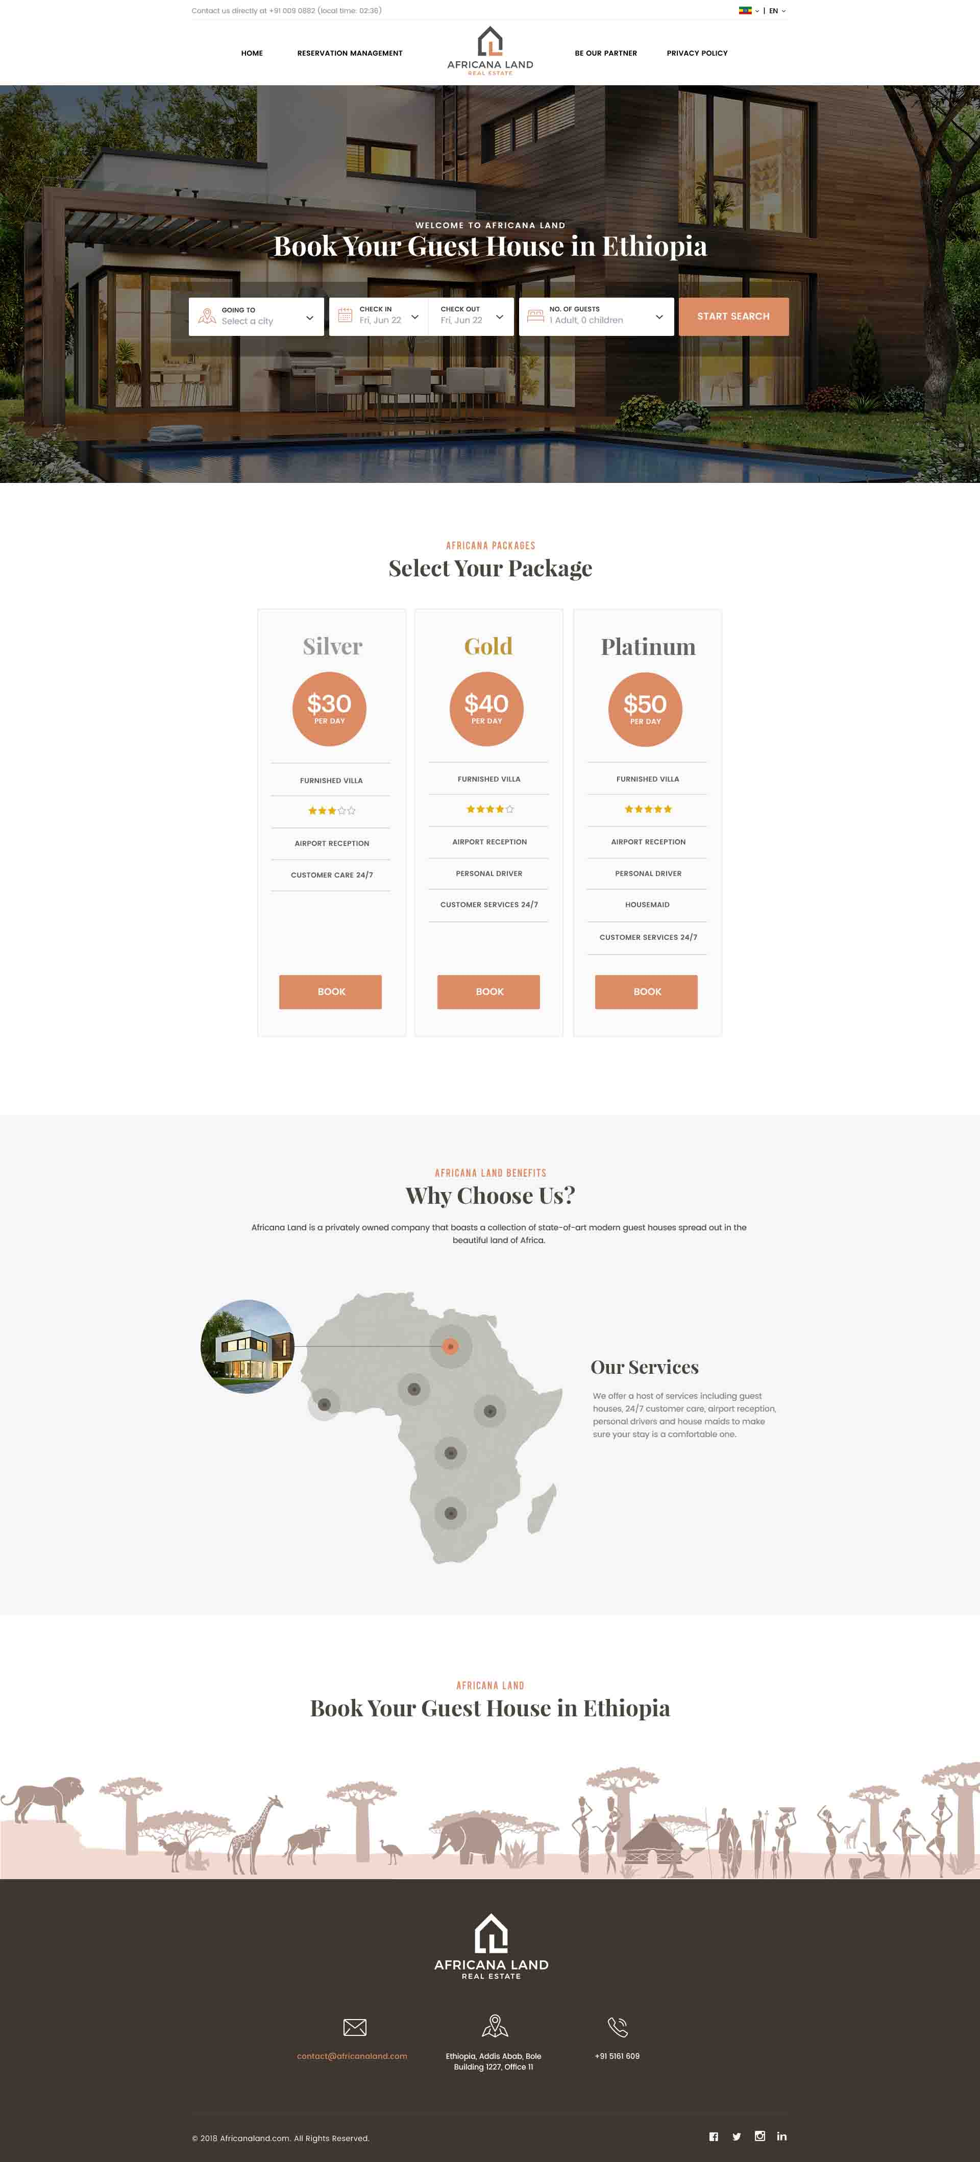

**Home page,**

User has 2 options for booking guest house.

The 1st options: user can select his destination (city) which added by the admin, then check in date and check out date. Select no of guests (adults and children), then press on Search button to search for available guest houses, select the suitable one for him.

The 2nd option, User may book in one step by pressing on Book button in packages. (user select his package silver, gold or platinum, then press on Book button of this package. Here, user will not see the any guest details. User cannot change additional services of the selected package. Ex: user select package silver, this package contains booking in furnished Villa with 3 stars. The cost of airport reception is included in total cost. He cannot remove it or cannot add other service like house maid.

**In Control Panel**, Admin change characteristics of every package. Admin activate or deactivate package. Only active packages appear in home page.

Admin can change email, address, phone & links of social media through Company Profile.

**In Control panel**, Admin add, update & delete cities through Cities management.

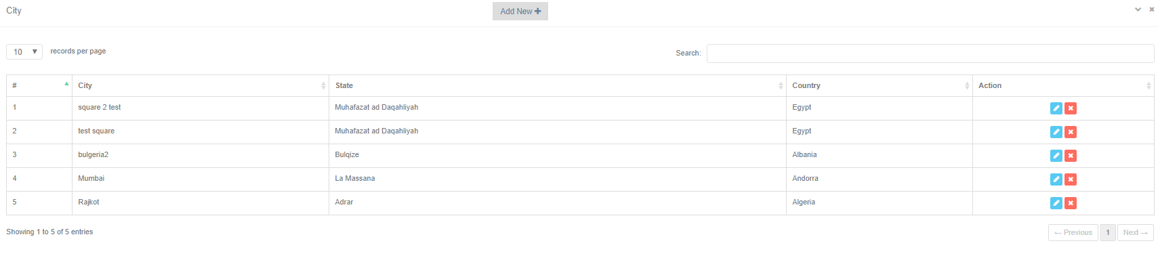

To add city, Admin press on City-> add city button from admin dash board. Admin select the country, state if the country has states like USA, then enter the name of the city and can save or cancel the city.

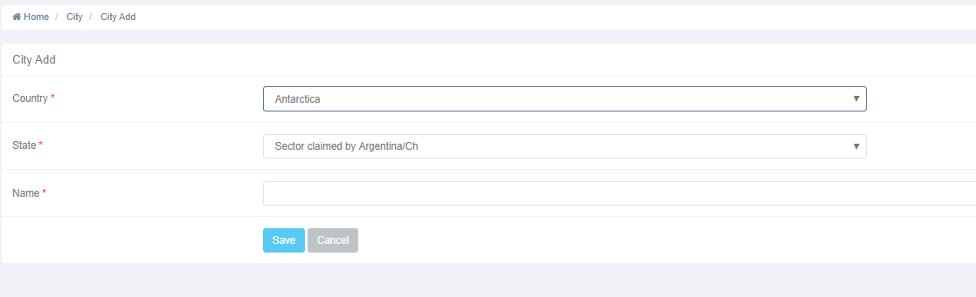



To update saved (existing) city, admin press on update icon to update the selected city.



Admin can delete a saved city be selecting delete icon on the city’s row.

Any changes here affect the system (front end) automatically.

Admin can change company data (email, phone , address) from company profile. He can also change links of social media icons (which appear at the right bottom of the pages)

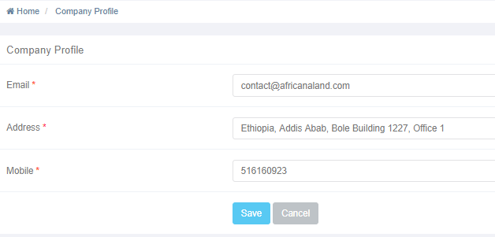

Any change here, appear automatically on the footer (at the bottom) of all pages. Also, admin can change contact us on phone no which appears at the top of all pages.

## **Developing Add Country (in Control panel):**

Cancel

Save

Enter password for confirmation

Retype password

PayPal and stripe (gateway) account information link

Enter phone

Phone

Gender

Mobile

Enter Franchisor Mobile

Franchisor Name

Enter Franchisor Full Name

Male Female

Enter Franchisor email

Email

Enter your Address

Enter his Password

Password

Address

Select City

City

Select your country

His Country

Note:

In Add users, Admin add sub-admin only. Franchisor in related to the country.

-admin can add franchisor from add country.

-Username of the franchisor will be his country name.

Working Country name

Select African Country Name

## Developing the Home page:

In case of changing this flag:

1-the phrase of “Book your guest house in Ethiopia” should be changed to be “in the selected country.

2- loaded cities below it, should be cities in that selected country.

3-guest houses appear after search, should be guest houses in this country.



Add Africana meals in packages. The included meals only appear in the package.

Replace icon of linked in to snapchat icon.

**Guest houses page (or named booking guide).**

After user make traditional search ( from search button), he is redirected to Guest houses page which contains all available guest houses in the selected period of time. All guest houses must be suitable for no of guests.

**In control panel**, Admin add guest house prosperities. Every guest house has max no. of guests. Ex: if user is searching for guest house for 4 guest. Only guest houses with max no of guests at least =4 appear. May have guest house with max no of guests =5 or 6 but not less than 4.

Any admin can add guest house with Pending status. The admin or subadmin have permission to approve or reject that guesthouse. Only approved guest houses appear here in booking guide page.

User can’t see pending guest houses till approved.

**In Booking guide page**, every approved guest house has image, price per night, button for Book, address, no. of parking, no. of beds, no. of bathrooms.

If user pressed on the image of the guest house, he should see pop up gallery of images of the selected guest house.

If user clicked on Book button, he should be redirected to guest house details page.

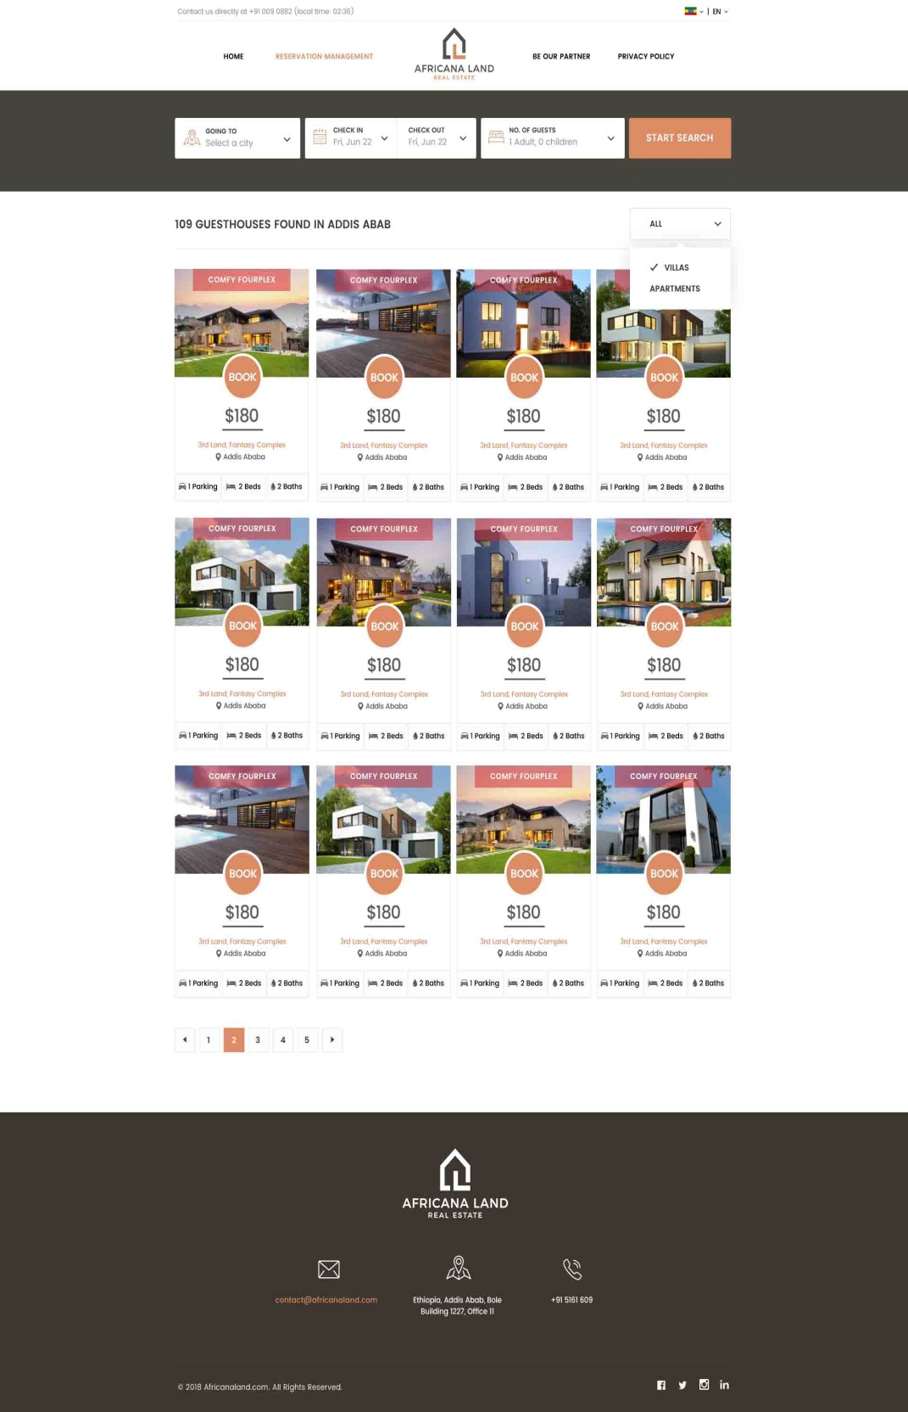

## Booking Guide Developing:

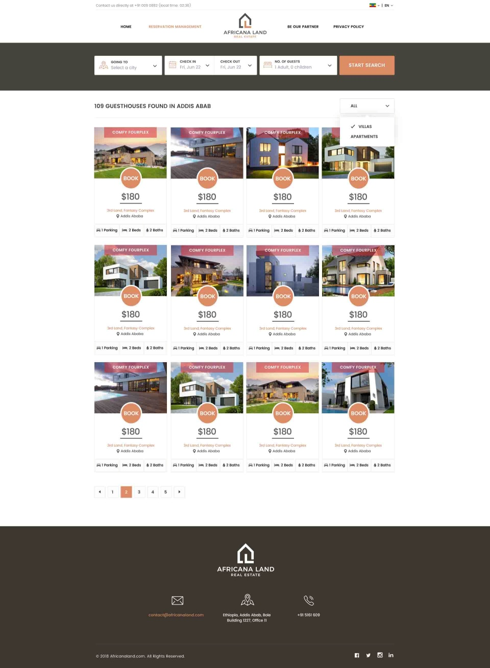

Add filters by:

* Stars
* Range of price
* No of bedrooms
* No of bathrooms

Add sort by drop down list:

* Price (highest to lowest)
* Lowest price to highest
* Stars(5 to 1)
* Stars (1 to 5)
* Best recommended (top reviewed)

- add star rate of every guest house below the price.

- on press on image of guest house, user should see gallery of images of that guest house.

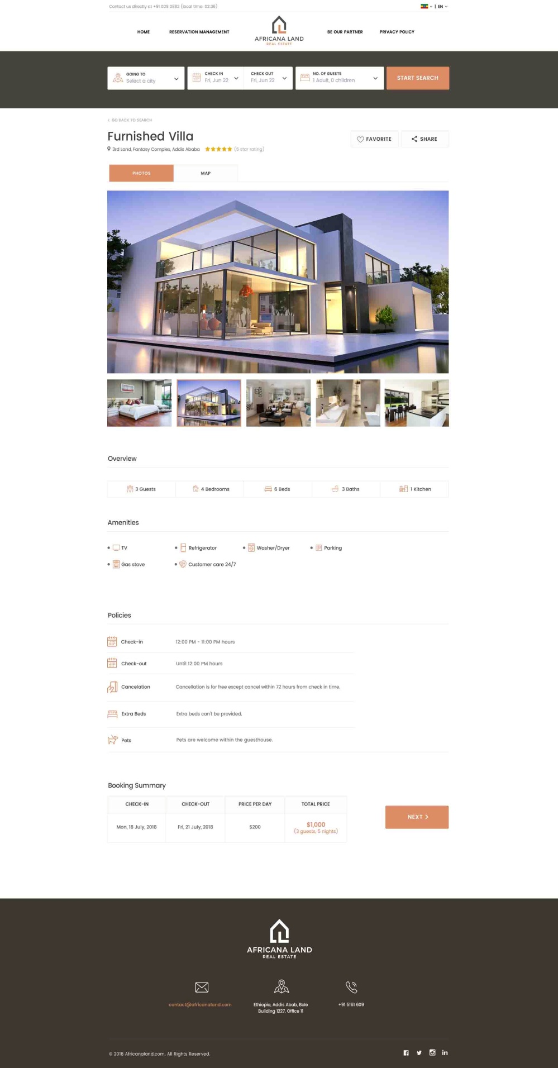

**Guest house page**

User sees details of the selected guest house to book it.

Gallery of images, map location of that guest house.

Overview data with max. no of guest, no of bedrooms, no of beds, no of bathrooms, no of kitchen.

User sees amenities of that guest house like TV, fridge, air conditioning, car parking and so on.

User can see descriptions of the selected guest house.

User also see policy of that guest house like check in time and check out time, children policy, animals policy and so on.

At the end of the page, user see summary of his selected booking criteria (options). To book the guest house, he press on “BOOK” button, then is redirected to “add additional services page” which appears as pop up.

**In control panel**, Admin add all characteristics of guest house like type (villa, apartment or house). Add guest house title, price per night, address, location, link of location on the map, country, city, upload images of the guest house, no of bedrooms, no of beds, no of bathrooms, max allowed no of guests, select amenities, add policies, add additional services with its price like house maid will cost 50 $ per night. The added guest house is pending till admin approves it to appear to users in search guide.

## Guest House Developing:

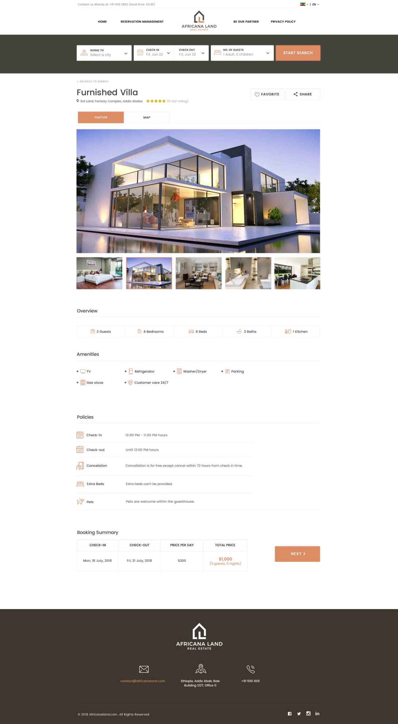

* Add Wi-Fi option in amenities (add name and its icon)
* Add total no of reservation of this guest house with ability to show or hide it.
* Review link
* Change the booking summary style.
* **Add additional service** separately as option in admin control panel. Should select the country, then additional service name in this country. Say, admin added additional services in Ethiopia. When admin select add guest house in Ethiopia, all added additional services should appear automatically with cost textbox to add/change the cost of the service.

**Additional service pop up**

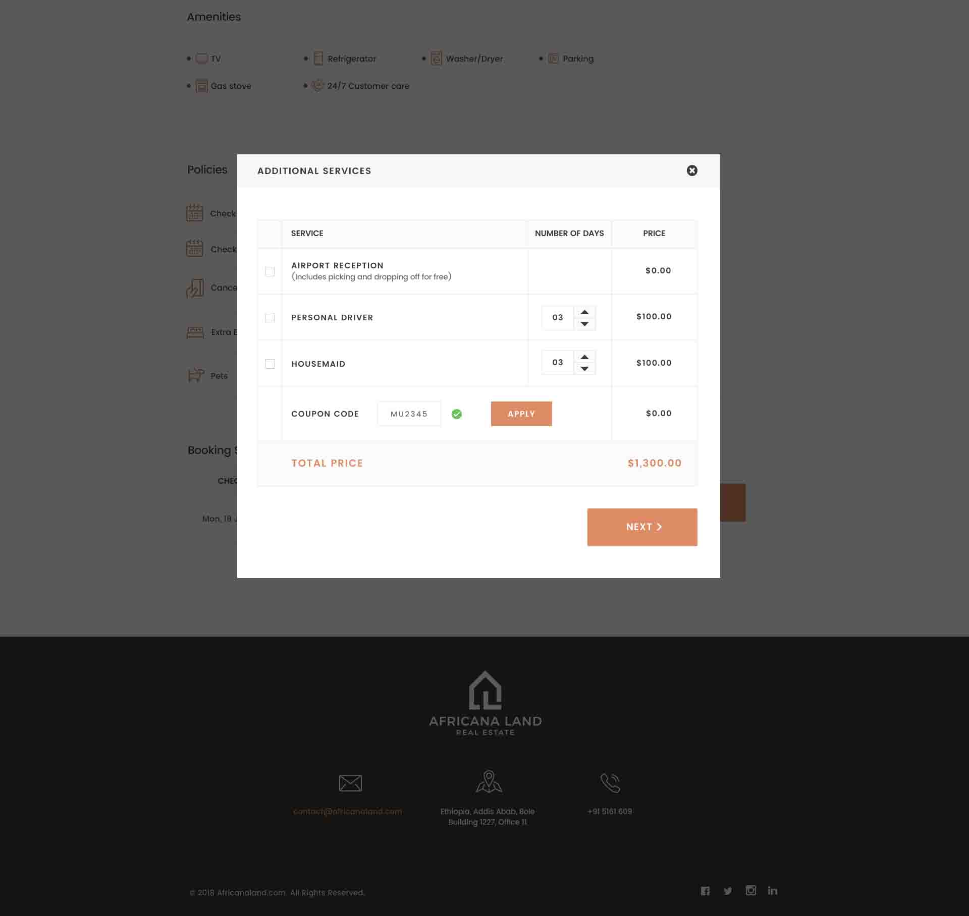

**Additional service pop up**

After user select book guest house, additional services pop up appears for him. It is loaded with added services by the admin from Add guest house in control panel.

User select his required services, the price is calculated automatically.

Here, user may add coupon code to decrease the total cost of his booking.

The user press Next to redirected to payment steps (enter his personal info, then select his payment type, then confirmation).

**In Control panel**, Admin add coupon details like discount percentage, coupon code, valid from date, valid to date.

**Ex**: if admin add coupon code of ABC123 with discount 30% and coupon valid from date 1/1/2019 to 10/1/2019.

This means that every time user adds this coupon code, the system check if the coupon is valid in the booking date or not. If valid decrease the total cost by 30% and so on.

## Additional Services Developing:

* Remove apply button, it should be automatically.
* Add Africana meals after house maid with options of **(every meal may have price or be free)**
  + Breakfast
  + Lunch
  + Dinner
* Size of Next button not suitable
* Add icon of coupon inside its textbox like pop up booking in case of package.

**In Control Panel**, coupon management, admin can see all coupons with all data.

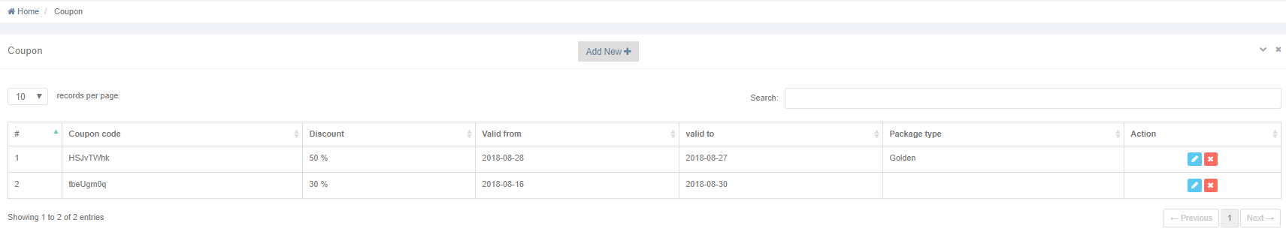

Admin can add new coupon by pressing on Add New button. Admin enters data of coupon (coupon code or system generate coupon code, enter percentage of the discount, select validation date of the coupon from date & to date).

Coupon can be applied on traditional search booking, or can be applied on packages. The discount percentage should decrease the total cost (cost of booking + cost of additional services if user selected additional services).

Every time, user use coupon code, the system check if the coupon is valid in these dates or not. If not, message appear to the user till him “This coupon code has expired”.



Admin can edit saved coupon date by pressing on update icon



Admin can delete coupon by pressing on delete icon

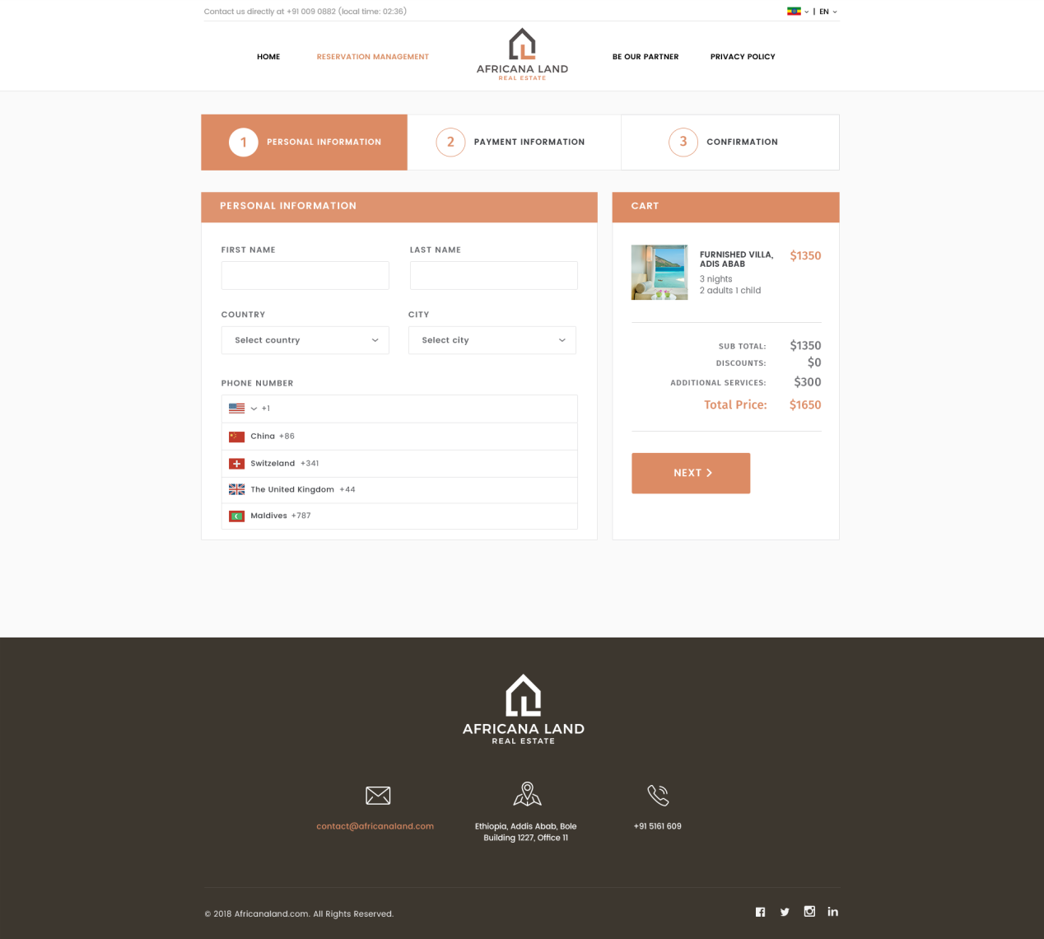

**Personal Information page**

The first step in paying money is entering Personal information including First name, last Name, select country, select the city, enter phone number, and email address.

Then, Press on Next button to select his payment method through payment Information page.

## Developing:

-The size of NEXT Button is not suitable.

- Add membership textbox here before first name, if true, write “VIP” for him next to it and load his personal data automatically.

Photos

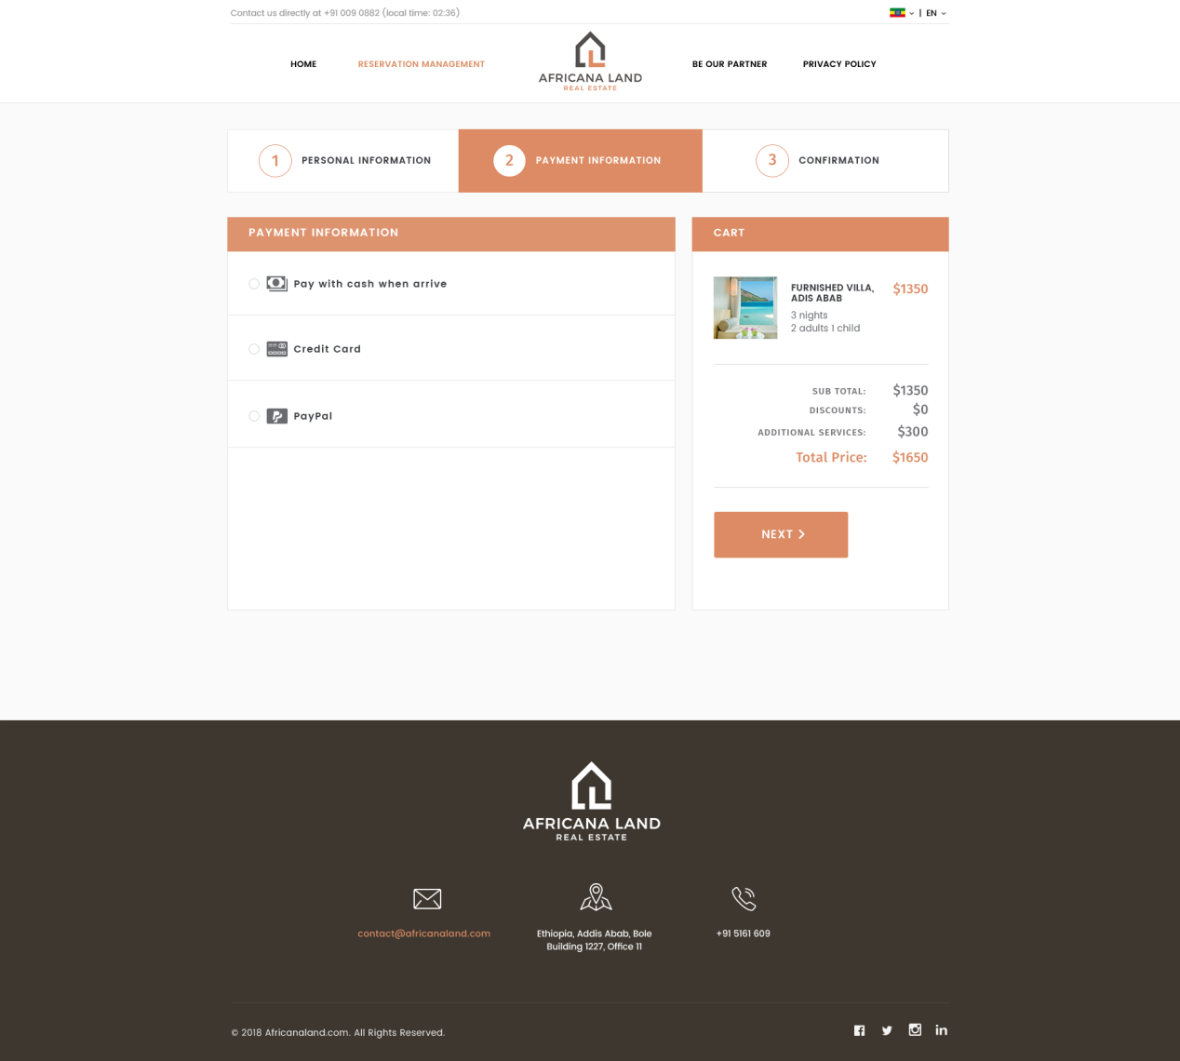

**Payment Information page**

User selects his payment method. He has 3 options.

1. Pay cash when arrive to the destinations.
2. Pay using credit card
3. Pay using PayPal account.

**In case of update his booking, refundable is allowed before 3 days of check in date.**

## Developing:

The size of NEXT Button is not suitable.

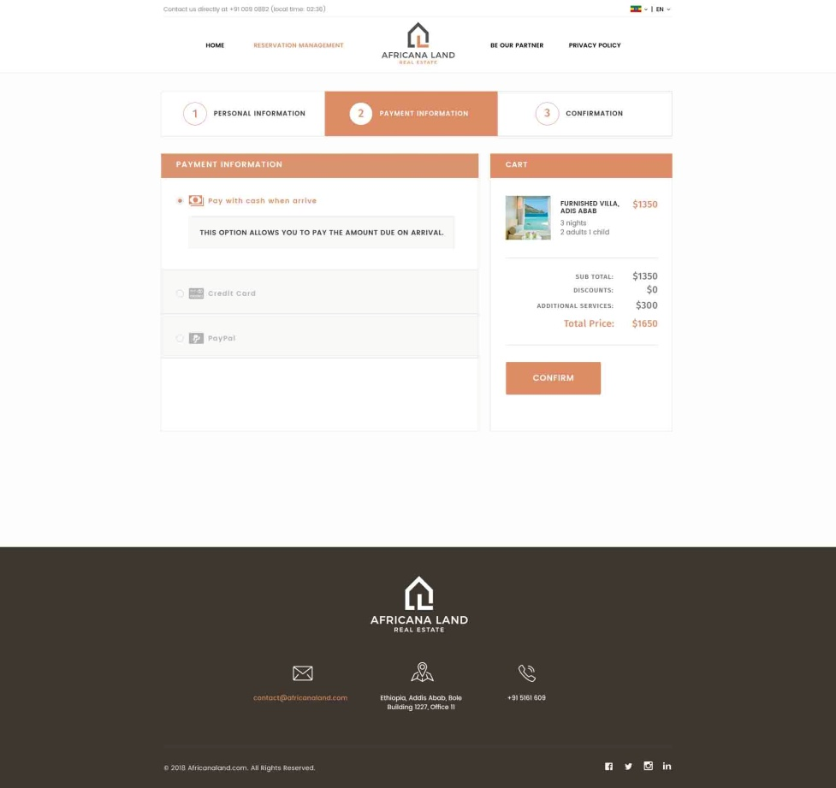

## Developing:

-The size of Confirm button is not suitable.

-Its text should be NEXT also.

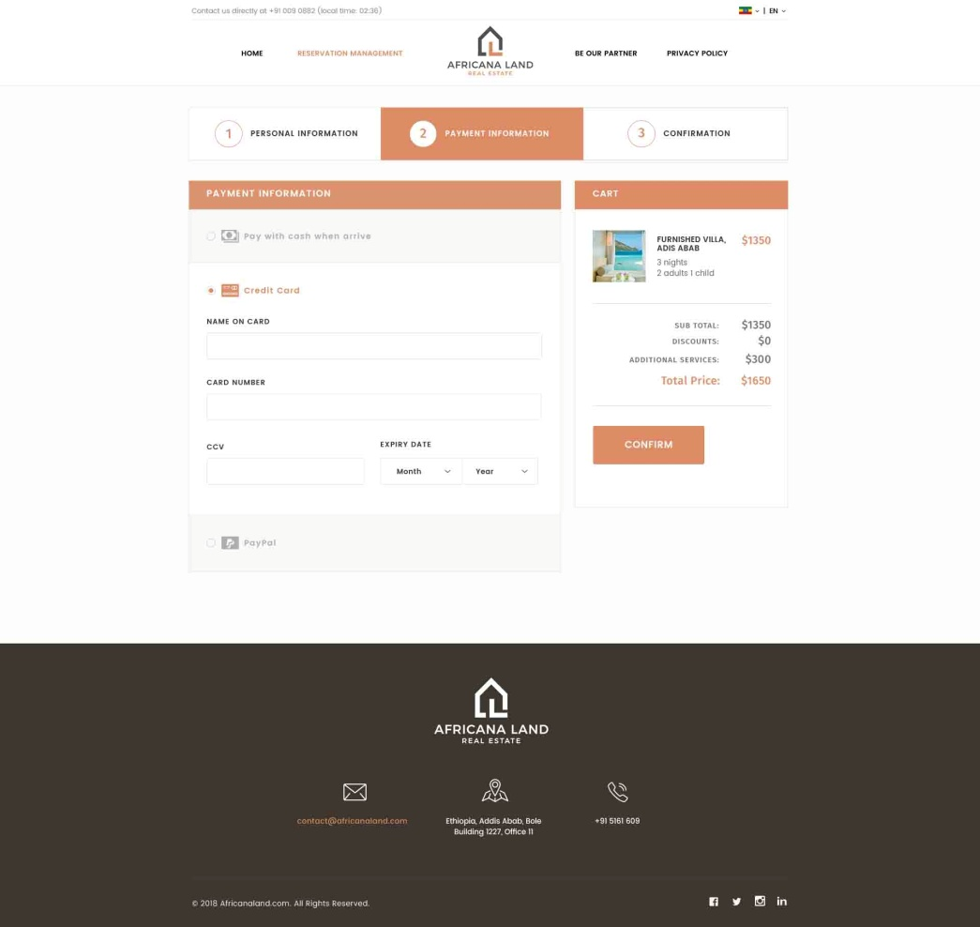

Developing:

-The size of Confirm button is not suitable.

-Should be NEXT also.

- When user writes card number, its type should appear automatically.

- CCV field is too long

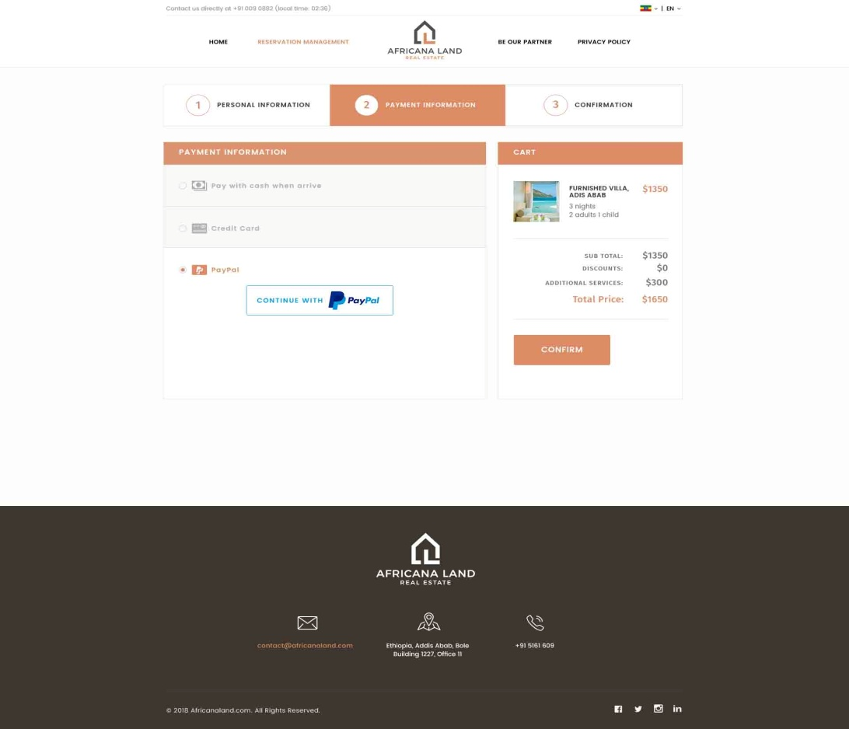

## Developing:

Confirm button should be minimized and renamed to be NEXT.

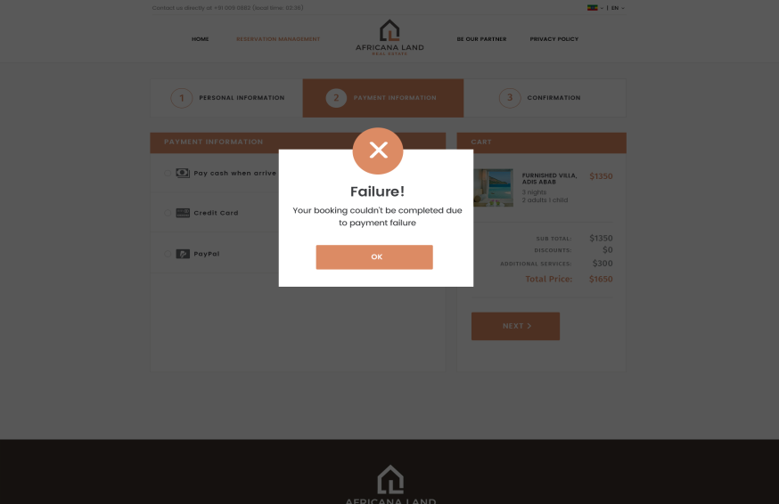

If the payment failed (in case of credit card payment or paypal ), this pop up appear for the user, and he is not redirected to confirmation page

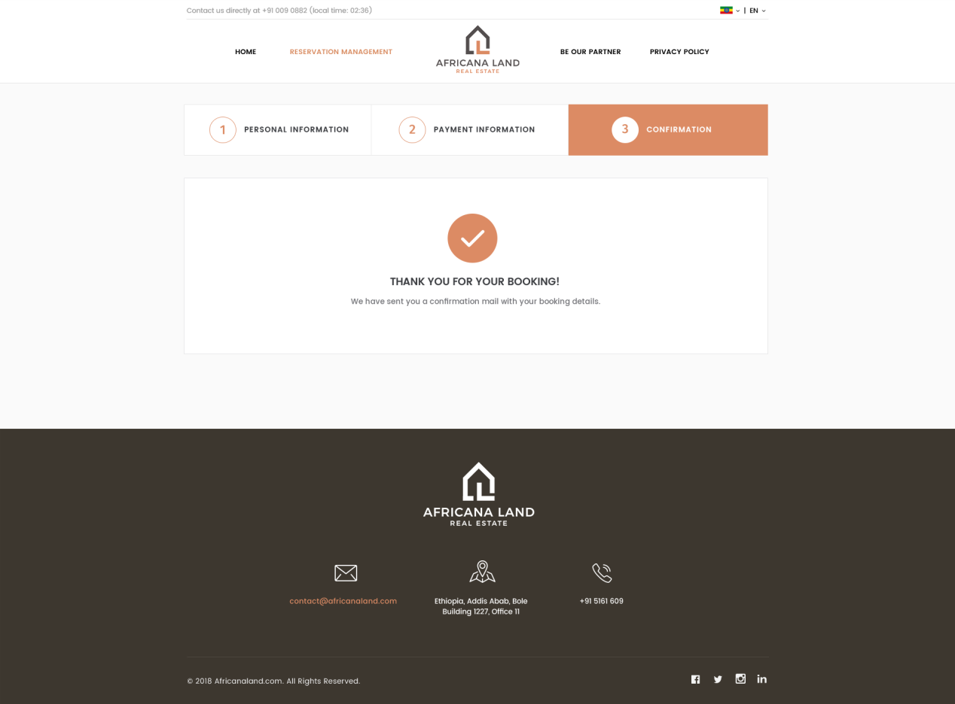

## Developing:

-Should add 2 buttons at the below of the page

* Print button (will template in pdf)

- Share button

-If booking done by VIP Client, add msg “VIP GUEST” before “THANK YOU FOR YOUR BOOKING”

**Confirmation page**

After selecting payment method and paid successfully, the system should send confirmation message of booking details automatically to the user.

Confirmation message with text “thank you for your booking” appear to the user including his booking Id.

User can update his booking by entering booking id in booking management page.

**In control panel**, Admin can see all booking information as it is saved in “Booking”

The confirmation template should be sent to the user after confirming the booking. In case of guest house and package (Silver, Gold & platinum).

/

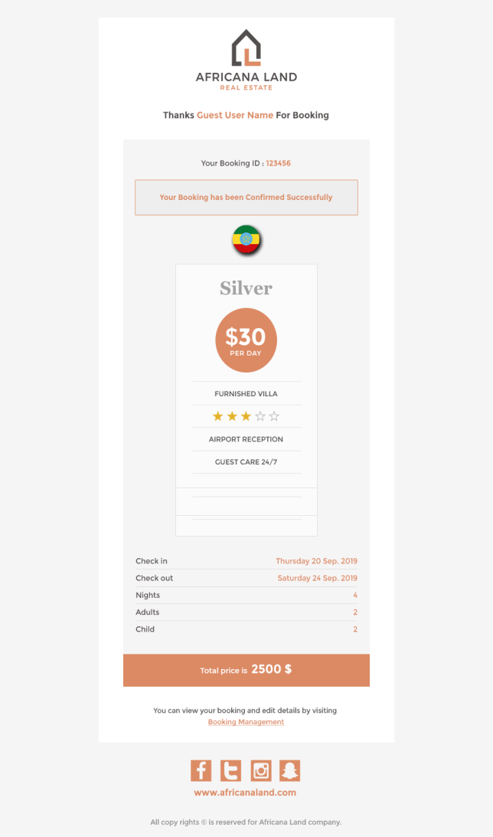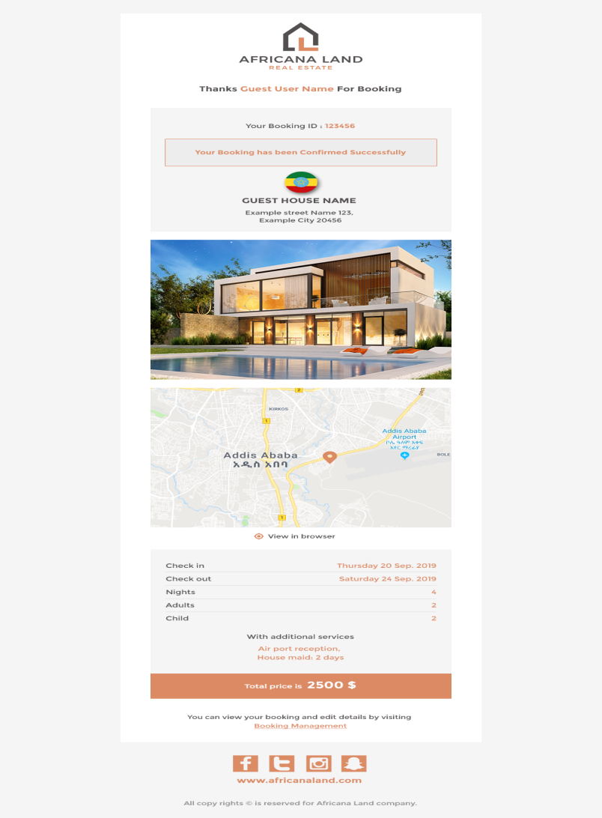

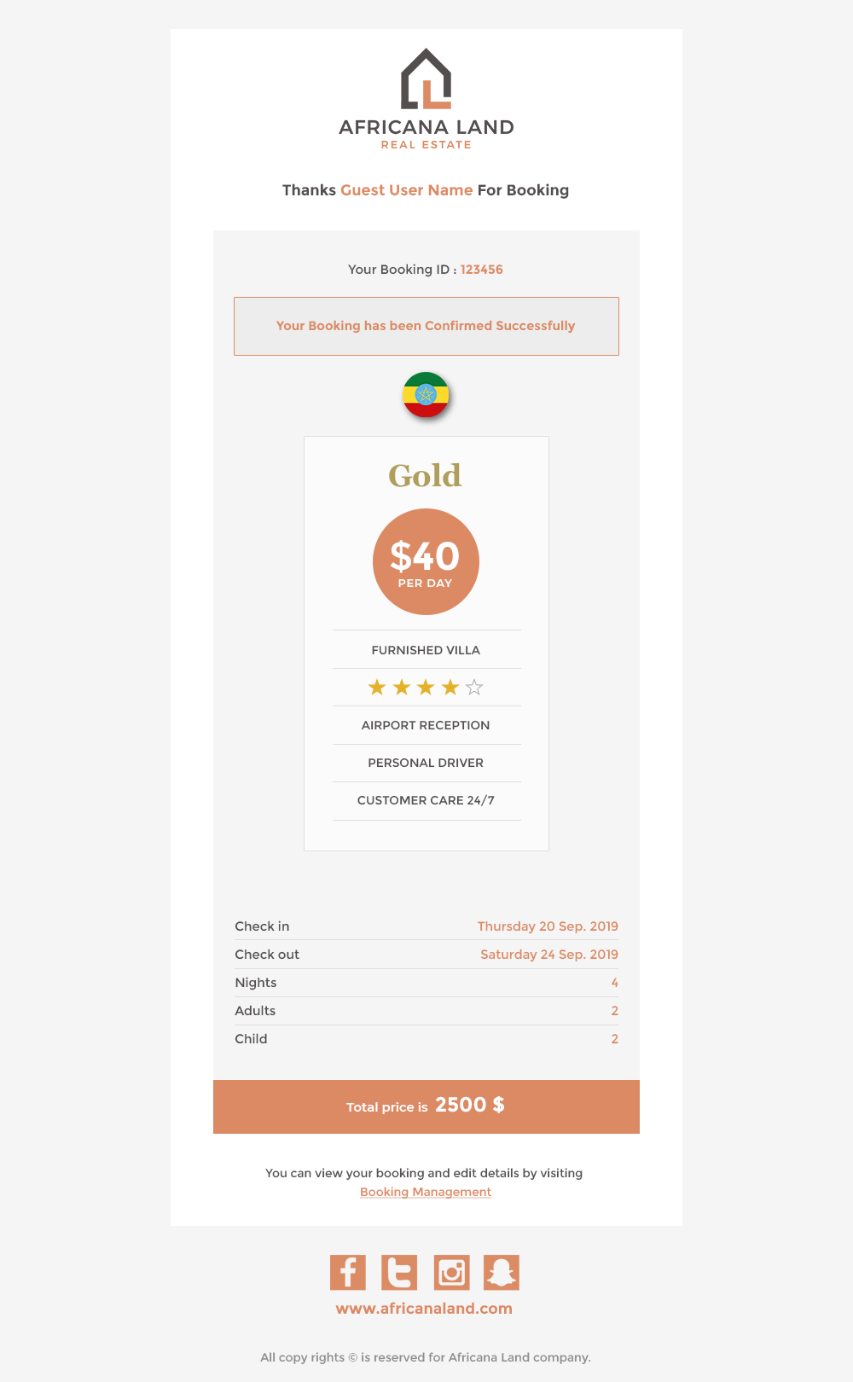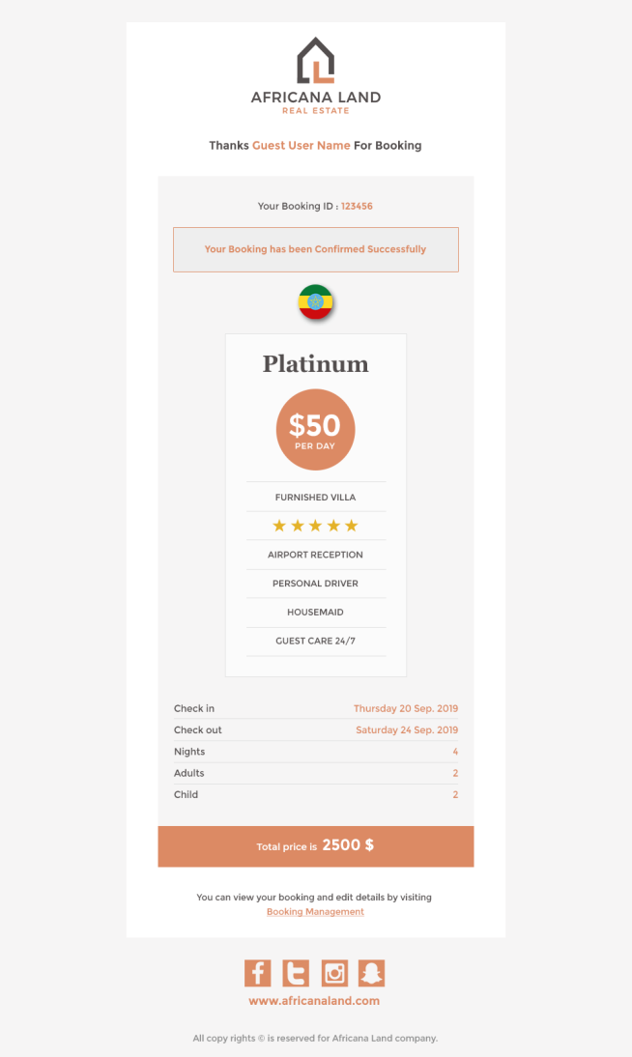Templates for gold & platinum package. **(this flag of the selected country from home page)**

## Developing email templates:

* Added meals should appear in additional services part.
* Add text “VIP GUEST” before “thanks…” in your style and formats.

**Booking management page**

The user can enter his booking Id in search by booking number, then press on search button.

The booked guest house appears for him with all its data including booking information data, personal data, payment method and selected additional services.

At the bottom of the page, user has 5 buttons. Modify personal information, change dates, change no of guests, edit service and cancel booking.

**In Control panel,** Admin see booking details from “Booking”.

## Developing

* Should add “Africana meals” part in additional services part.
* Change price to be total price.

C:\Users\Mahmoud\Desktop\Dropbox\‏‏Africana Land\IT\Website\Documents\Website Porposal2\40.tif

User should see something like that

**Dear our guest please notes that in case of Modifying or cancellation:**

**You have to modify before 3 days of your check in date**

**Update personal Information pop up**

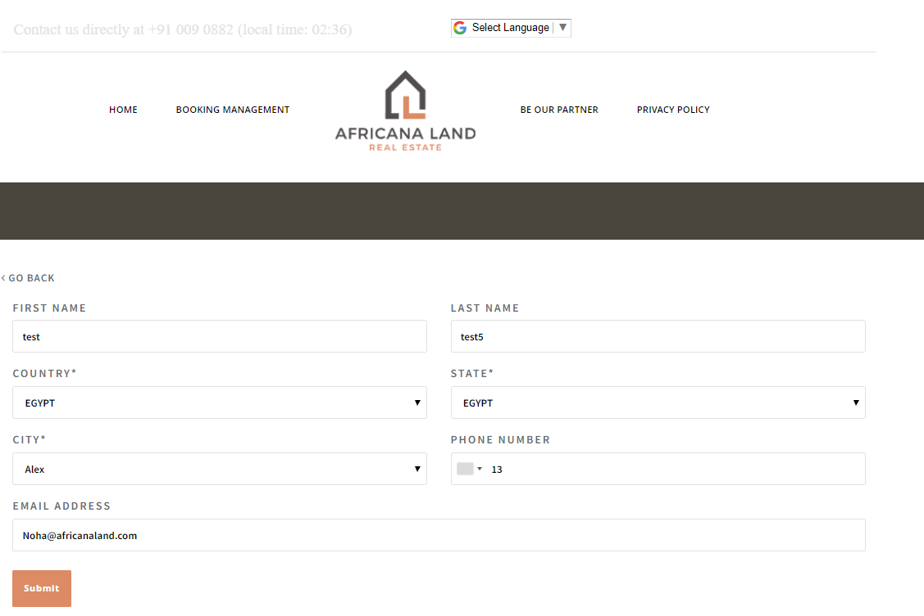

If user pressed on update personal information, pop up of personal details appear for him, loading all previous saved data. The user can change any data, then save or close without saving.

After any updates in Booking, the system should send confirmation message with changed details automatically to the user.

**Change dates pop up**

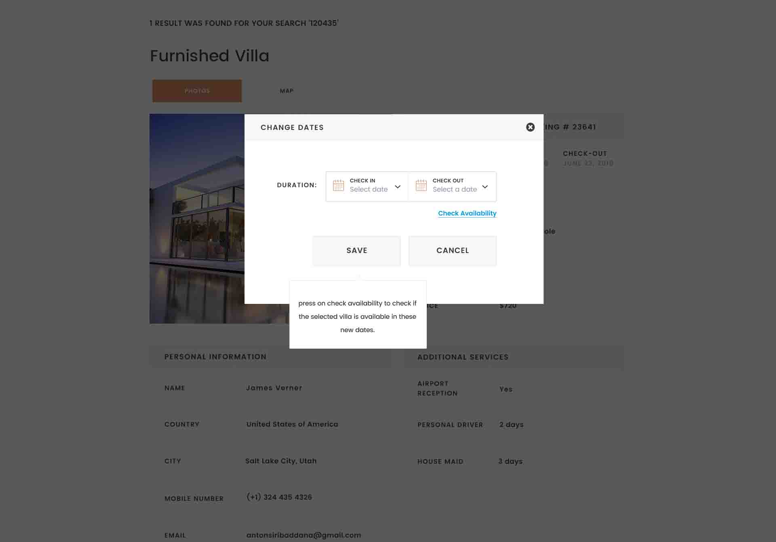

In case of changing dates, the user must select Check Availability button, to check if the guest house is available in that new dates or not. If not, pop up appear for him with messages “please, Change Your Dates As This Guest House Is Reserved.”

If the guest house is available in new dates, allow user to book in these new dates.

Enables button Save & cancel after checking availability.

**In Control Panel**, every update appears in the control panel in page “Book”.

Developing:

In case of changing date to unavailable date, user should show message like this:

“The guest house in not available before 1/1/2019”

After enabling save button

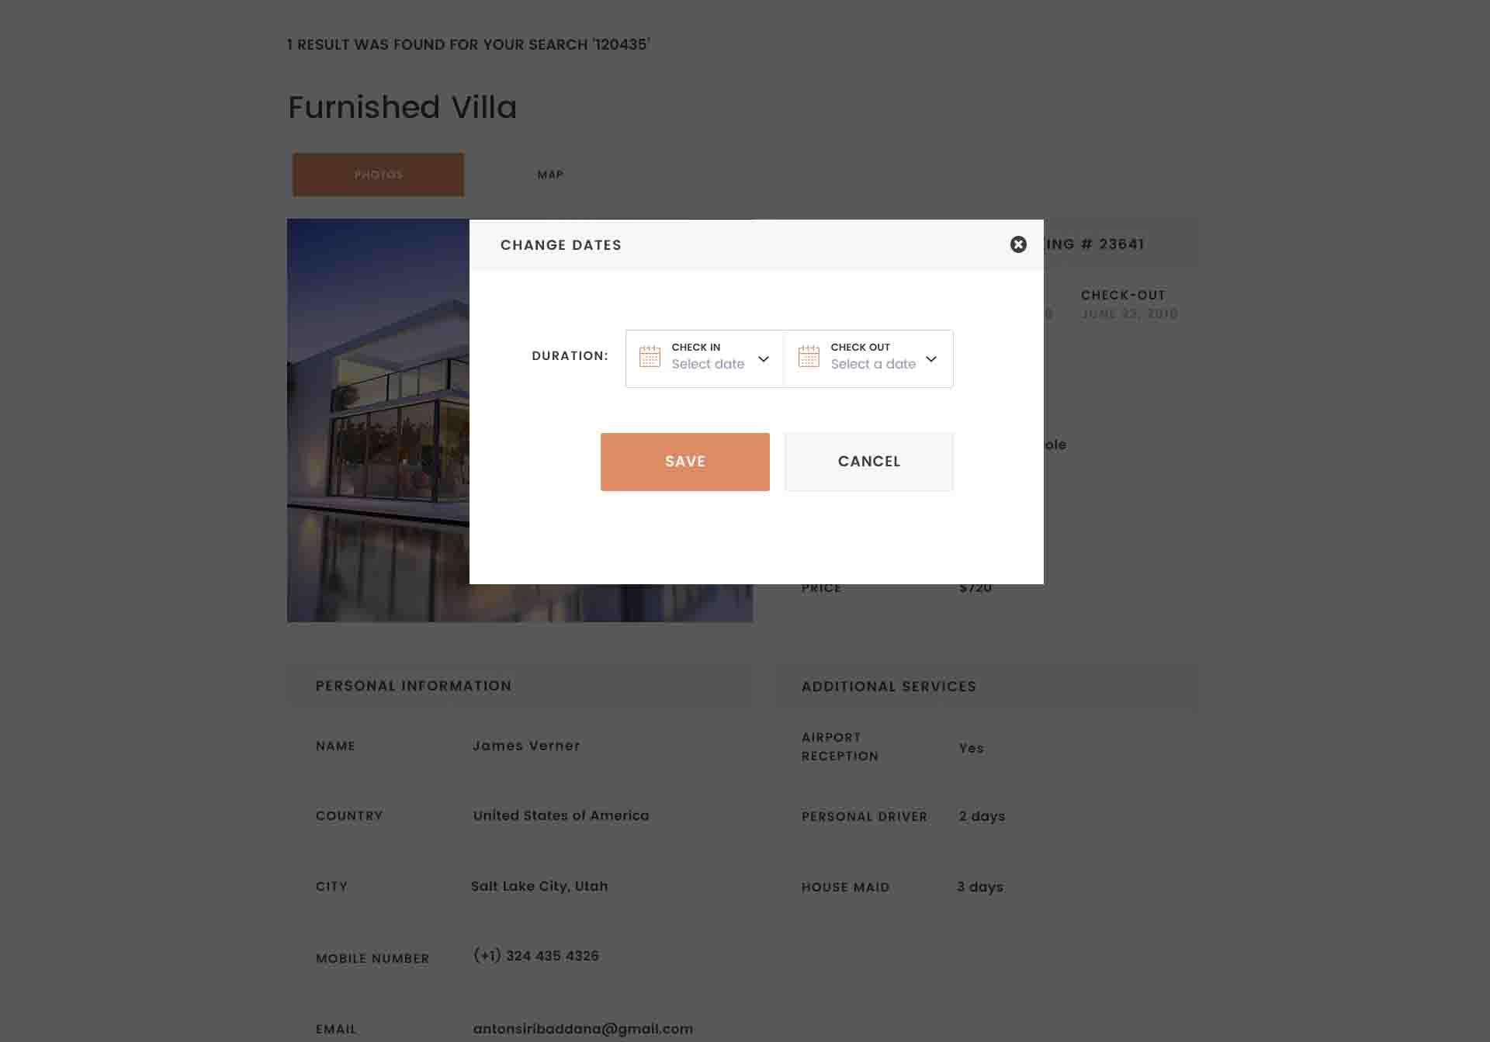

**Update number of guests:** appear as pop up

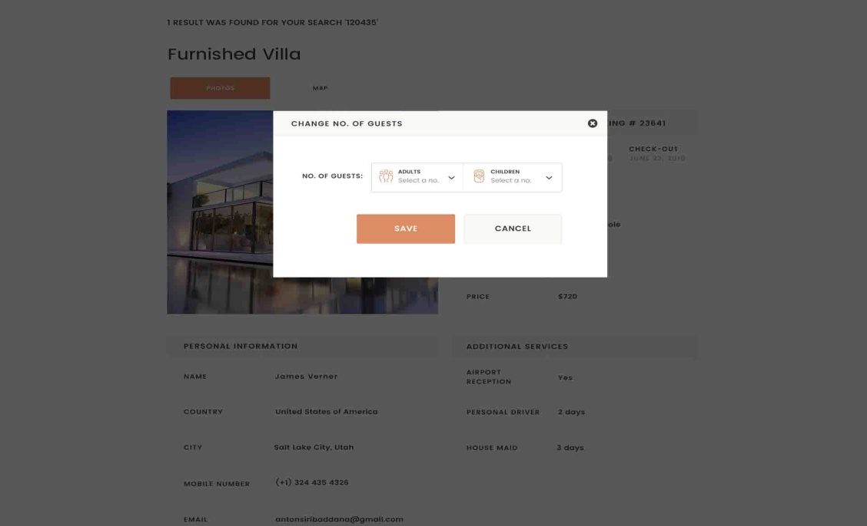

**Edit services pop up:**

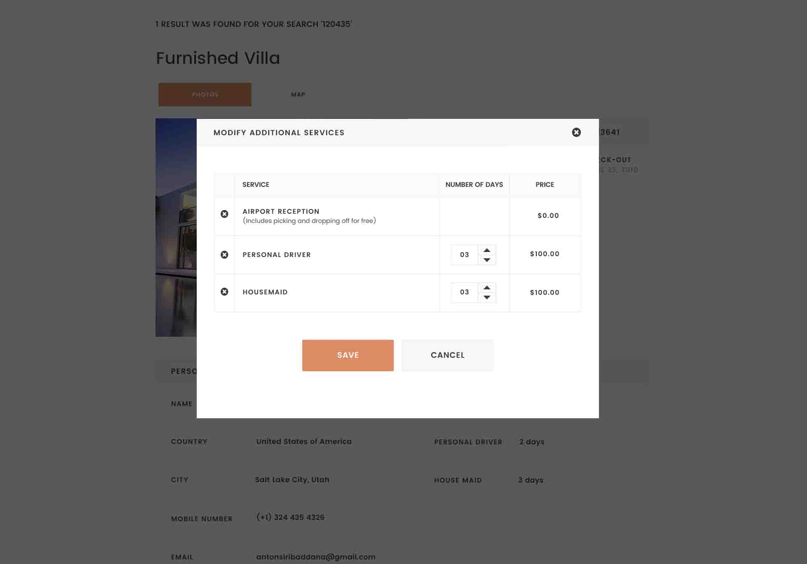

Developing:

- Add coupon code

- Add African meals here after airport reception with its cost.

Appear to the user with all previous saved data. The user can change (select or deselect or change) any service. The total cost appears for him. He may add coupon code to decrease total cost (cost of booking + cost of additional services).

In control panel, any change reflects (appear) automatically in control panel Booking page.

After any updates, pop up of update successfully appear to the user and email of the updates send to the user.

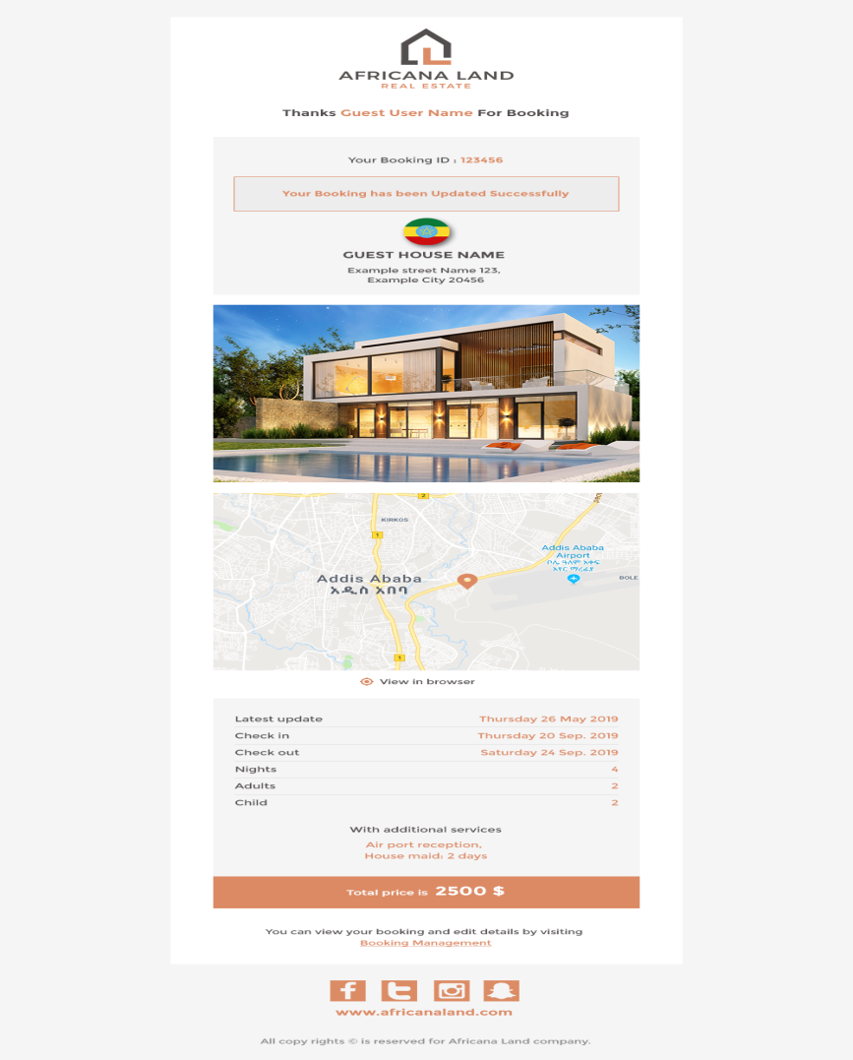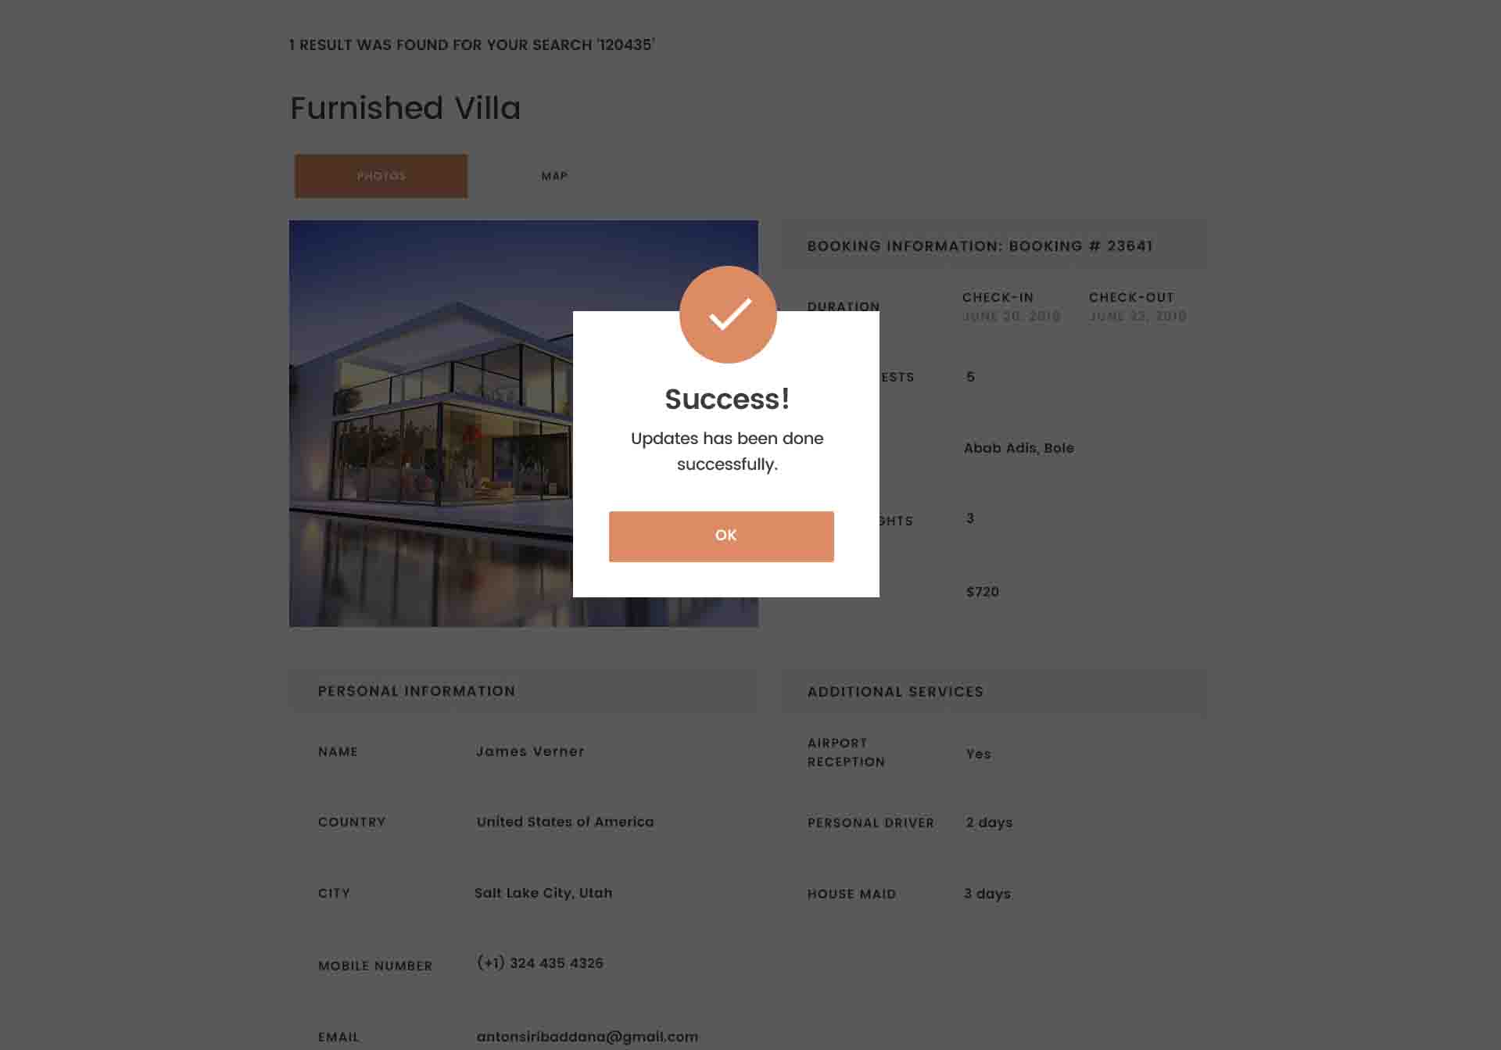

## Developing email template:

- add “VIP GUEST” before thanks guest name incase of he was a VIP.

**Cancel Booking:**

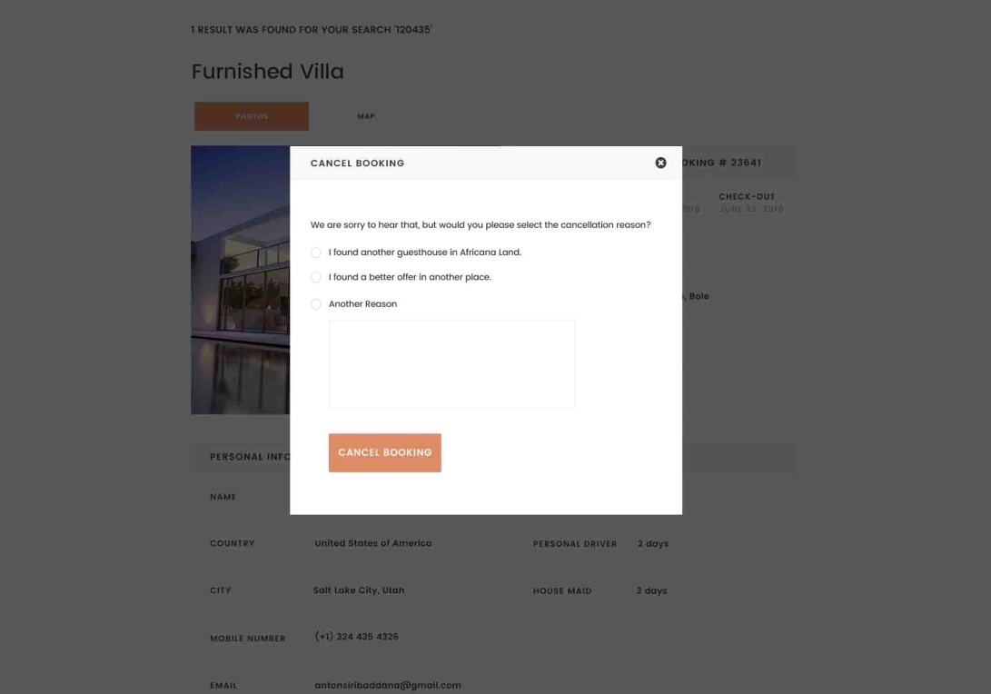

If user select cancel booking, pop up appear for him asking him about the reason, then if he canceled the booking, the system send confirmation email to him automatically.

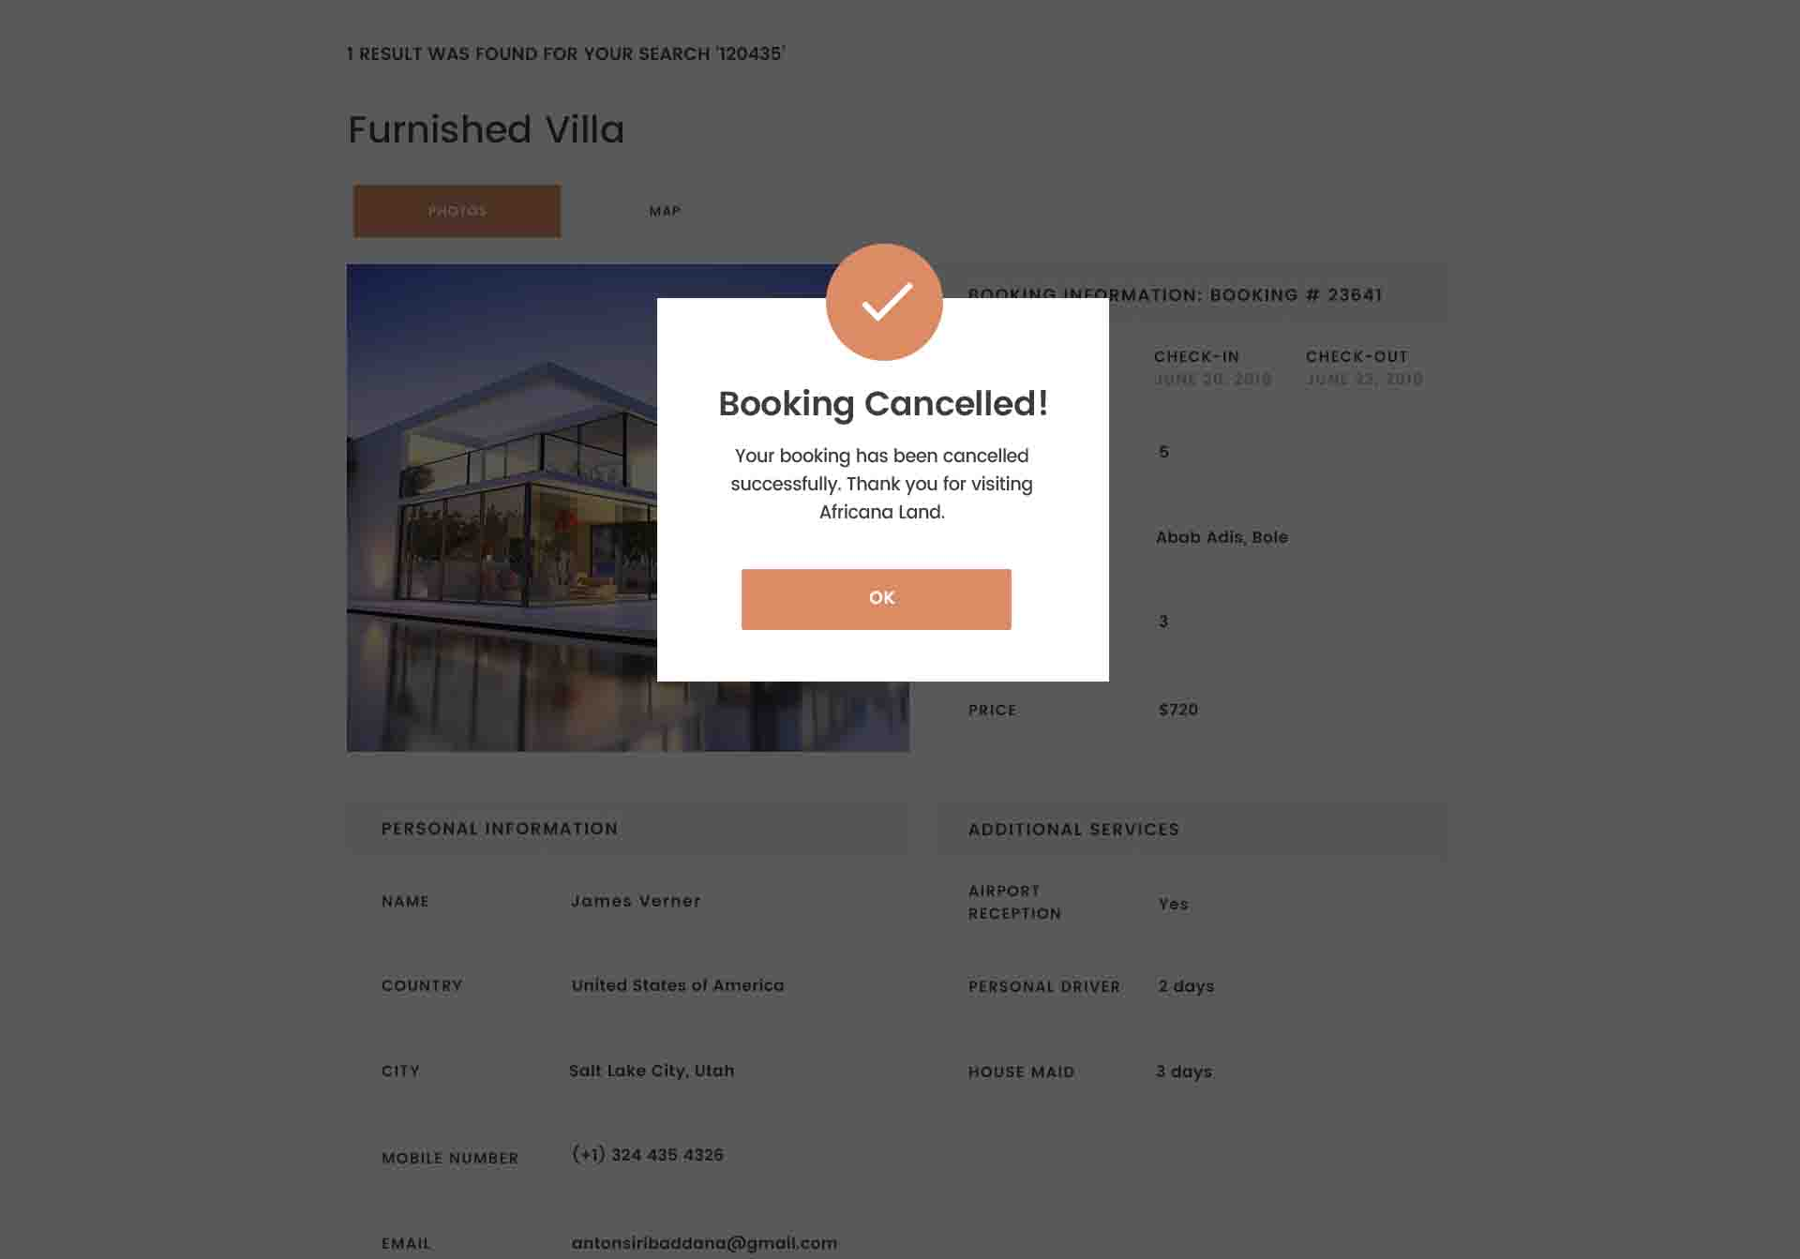

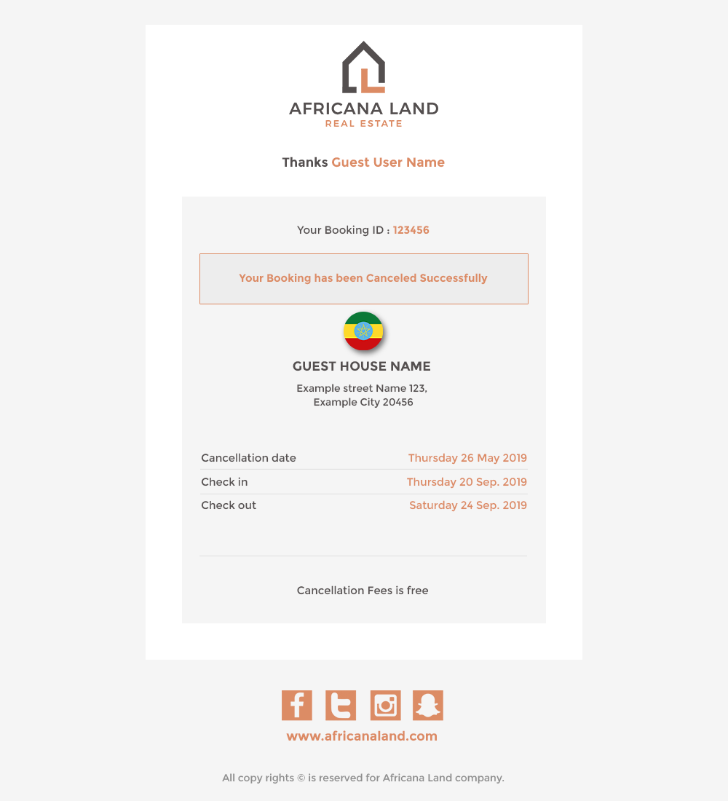

The email template in case of booking cancellation.

## Developing email template:

-if he was VIP, add “VIP GUEST” before text of thanks guest name in your design.

**The user can book package (silver, gold , platinum) by selecting his preferred package then press on “BOOK” button of this package.**

**These packages are activated packages only. If the admin deactivate package, it shouldn’t appear in home page.**

**This part in home page is packaging part**

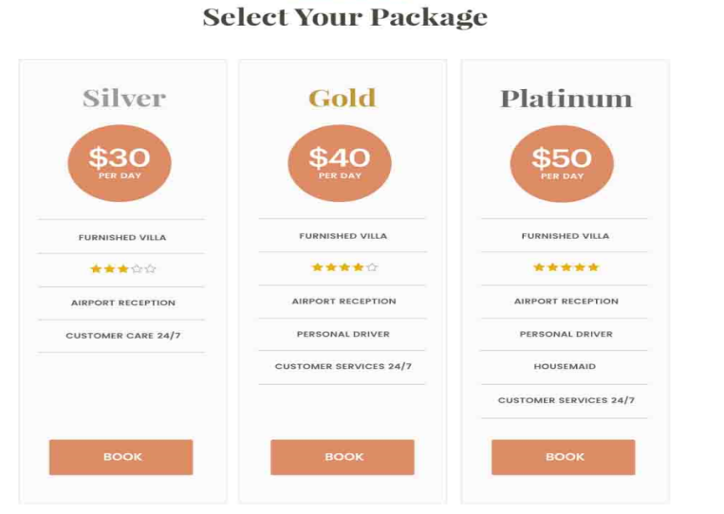

## Developing:

Add included African meals.

When the user click Book, pop up appear asking him to enter his booking information

**In control Panel**, Admin can change data of packages (stars, price, included additional services, activate or deactivate package)

**Booking information pop up**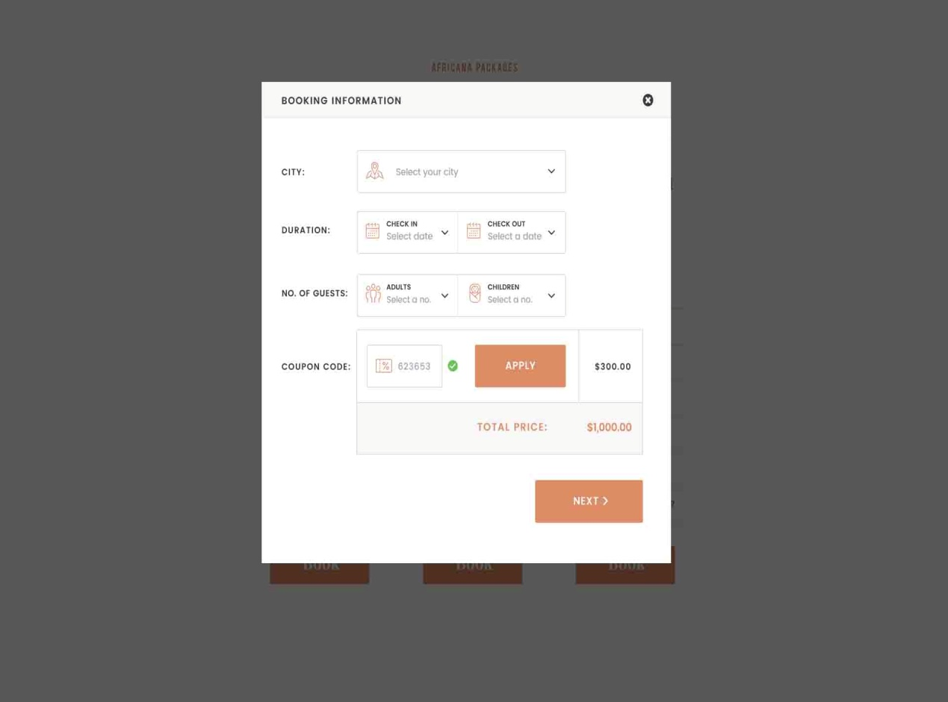

Is asking user to select the city, his check in date, check out date, coupon code is not mandatory. Then press on Next button.

After pressing on Next button, the user is redirected to enter personal information, payment information and confirmation. If the user booked “Silver” package, the personal information and payment information pages are loaded with “Silver style in the right part”

If the user booked “GOLD” package, the personal information and payment information pages are loaded with “GOLD style in the right part”

If the user booked “PLATINUM” package, the personal information and payment information pages are loaded with “PLATINUM style in the right part”

**Personal Information in case of silver package**

## Developing:

The size of confirm button should be same as in traditional search

Same for all packages.

Add text box for membership number.if user enetered it, write “VIP” for him and upload his personal data automatically. Allow him to update, then in case pressing Next btn, save his updated data.

C:\Users\Mahmoud\Desktop\Dropbox\‏‏Africana Land\IT\Website\Documents\Website Porposal2\image18.tiff

**Personal Information in case of GOLD package**

## Developing:

The size of confirm button should be same as in traditional search

Same for all packages.

Add text box for membership number.if user enetered it, write “VIP” for him and upload his personal data automatically. Allow him to update, then in case pressing Next btn, save his updated data.

C:\Users\Mahmoud\Desktop\Dropbox\‏‏Africana Land\IT\Website\Documents\Website Porposal2\image19.tiff

**Personal Information in case of PLATINUM package**

## Developing:

The size of confirm button should be same as in traditional search

Same for all packages.

Add text box for membership number.if user enetered it, write “VIP” for him and upload his personal data automatically. Allow him to update, then in case pressing Next btn, save his updated data.

C:\Users\Mahmoud\Desktop\Dropbox\‏‏Africana Land\IT\Website\Documents\Website Porposal2\image20.tiff

**The same Idea in payment Information**

**Payment Information in case of silver package**

## Developing:

* The size of confirm button should be same as in traditional search
* Same for all packages.

C:\Users\Mahmoud\Desktop\Dropbox\‏‏Africana Land\IT\Website\Documents\Website Porposal2\image21.tiff

**Payment Information in case of GOLD package**

## Developing:

* The size of confirm button should be same as in traditional search
* Same for all packages.

C:\Users\Mahmoud\Desktop\Dropbox\‏‏Africana Land\IT\Website\Documents\Website Porposal2\image22.tiff

**Payment Information in case of PLATINUM package**

## Developing:

* The size of confirm button should be same as in traditional search
* Same for all packages.

C:\Users\Mahmoud\Desktop\Dropbox\‏‏Africana Land\IT\Website\Documents\Website Porposal2\image23.tiff

**In case of selecting payment method- pay cash – silver package**

C:\Users\Mahmoud\Desktop\Dropbox\‏‏Africana Land\IT\Website\Documents\Website Porposal2\image24.tiff

## Developing:

* The size of confirm button should be same as in traditional search
* Same for all packages.

**in case of selecting payment method- pay cash – GOLD package**

## Developing:

* The size of confirm button should be same as in traditional search
* Same for all packages.

C:\Users\Mahmoud\Desktop\Dropbox\‏‏Africana Land\IT\Website\Documents\Website Porposal2\image25.tiff

**In case of selecting payment method- pay cash – PLATINUM package**

C:\Users\Mahmoud\Desktop\Dropbox\‏‏Africana Land\IT\Website\Documents\Website Porposal2\image26.tiff

## Developing:

* The size of confirm button should be same as in traditional search
* Same for all packages.

**In case of selecting payment method- pay by credit card – silver package**

Developing:

-The size of Confirm button is not suitable.

-Should be NEXT also.

- When user writes card number, its type should appear automatically.

- CCV field is too long

C:\Users\Mahmoud\Desktop\Dropbox\‏‏Africana Land\IT\Website\Documents\Website Porposal2\image27.tiff

**In case of selecting payment method- pay by credit card – GOLD package**

Developing:

-The size of Confirm button is not suitable.

-Should be NEXT also.

- When user writes card number, its type should appear automatically.

- CCV field is too long

C:\Users\Mahmoud\Desktop\Dropbox\‏‏Africana Land\IT\Website\Documents\Website Porposal2\image28.tiff

**In case of selecting payment method- pay by credit card – PLATINUM package**

Developing:

-The size of Confirm button is not suitable.

-Should be NEXT also.

- When user writes card number, its type should appear automatically.

- CCV field is too long

C:\Users\Mahmoud\Desktop\Dropbox\‏‏Africana Land\IT\Website\Documents\Website Porposal2\image29.tiff

**In case of selecting payment method- Pay Pal – SILVER package**

## Developing

The size of confirm button should be same as in traditional search

Same for all packages.

C:\Users\Mahmoud\Desktop\Dropbox\‏‏Africana Land\IT\Website\Documents\Website Porposal2\image30.tiff

**In case of selecting payment method- Pay Pal – GOLD package**

C:\Users\Mahmoud\Desktop\Dropbox\‏‏Africana Land\IT\Website\Documents\Website Porposal2\image31.tiff

## Developing

The size of confirm button should be same as in traditional search

Same for all packages.

**In case of selecting payment method- Pay Pal – PLATINUM package**

## Developing

The size of confirm button should be same as in traditional search

Same for all packages.

C:\Users\Mahmoud\Desktop\Dropbox\‏‏Africana Land\IT\Website\Documents\Website Porposal2\image32.tiff===========

If failure in booking, pop up appear like this

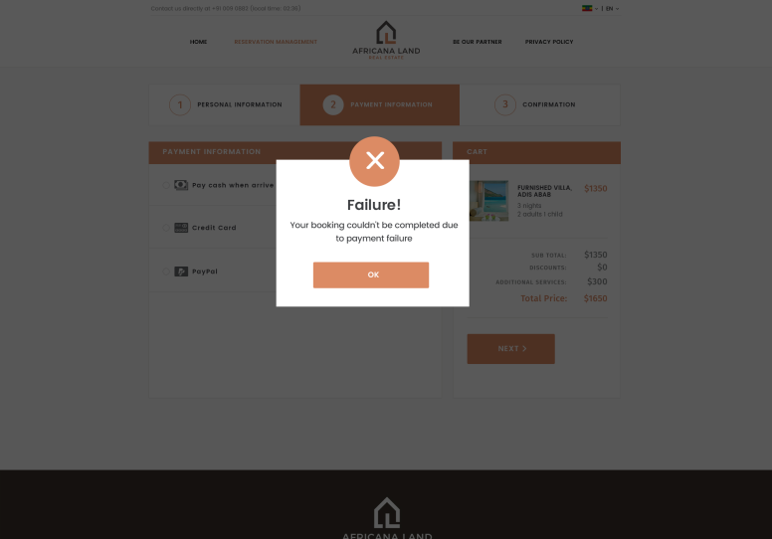

Then, the user is redirected to confirmation page (same confirmation page incase of booking from traditional search by pressing on Search button).



**Confirmation page**

After selecting payment method, the system should send confirmation message of booking details automatically to the user.

Confirmation message with text “thank you for your booking” appear to the user including his booking Id.

User can update his booking by entering booking id in booking management page.

**In control panel**, Admin can see all booking information as it is saved in “Booking”.

## Developing:

Should add 2 buttons at the below of the page

* Print button
* Share button

- if was VIP, add text ” VIP GUEST” before “thanks VIP Client Name in your design

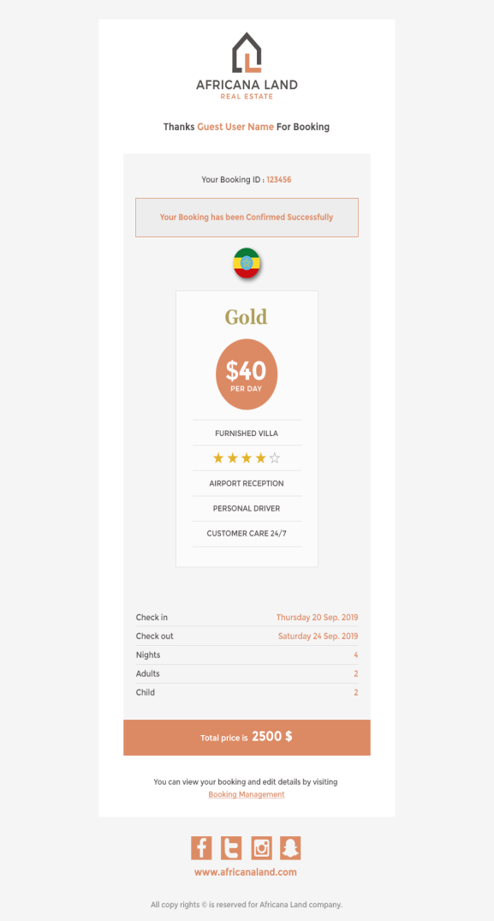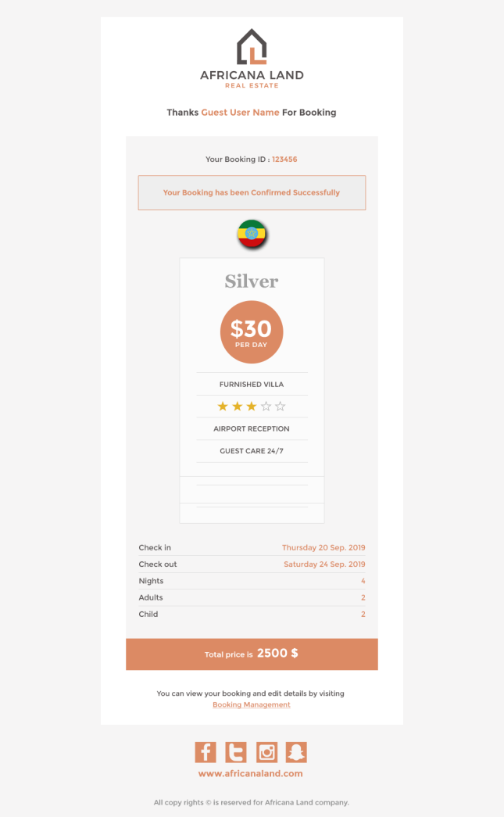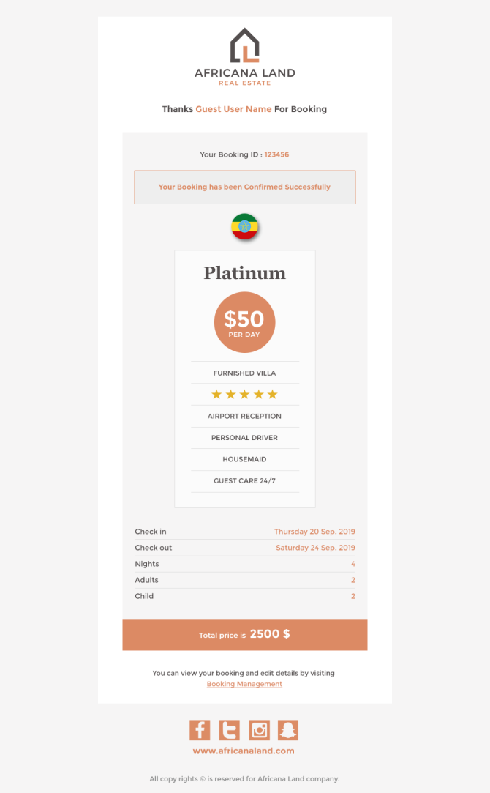The confirmation email template is send to the user after redirect to the confirmation page.

## Developing all email templates:

- add African meals if it is included in packages.

-African meals should appear here after house maid.

-all packages are in same PSD file.

-if he was VIP adds “VIP GUEST” before “Thanks guest name” for all templates.

In Control Panel, all booking details are saved and can be seen from “Booking” button in admin part.

The user can enter his booking Number in “Booking Management” then press on “Search” button to show details of his booking. He also can update any data in booking like traditional booking management.

Booking management in case of packages is very similar to booking management in case of traditional booking but with 2 differences.

1. In case of package, the user can’t select, deselect or change additional details as he select the package as whole with all its included services.
2. No images of the booked guest house as the user didn’t book a specific guest house. Ex: user booked a villa of “Silver” package with 3 stars. Any 3 stars villa.
3. The upper left corner (which in traditional booking management shown the booked villa) is styled in same style of the booked package (silver style in case of silver package, gold style in case of Gold package & platinum in case of platinum package).

**Booking management in case of booked silver package**

## Developing:

Add meals in services part if it is included

C:\Users\Mahmoud\Desktop\Dropbox\‏‏Africana Land\IT\Website\Documents\Website Porposal2\image33.tiff

**Booking management in case of booked GOLD package**

## Developing:

Add meals in services part if it is included

C:\Users\Mahmoud\Desktop\Dropbox\‏‏Africana Land\IT\Website\Documents\Website Porposal2\image34.tiff

**Booking management in case of booked PLATINUM package**

## Developing:

Add meals in services part if it is included

C:\Users\Mahmoud\Desktop\Dropbox\‏‏Africana Land\IT\Website\Documents\Website Porposal2\image35.tiff

The user can update personal information, update date of check in and check out, change no of guests, change the selected package, cancel booking.

Change date, user select check in dateand check out date. No need here to check availability as no specific guest house booked.



After changing date, the system should sent confirmation message automatically to the user with details of new updated dates.

Change no of guests in traditional booking and in packages is the same.

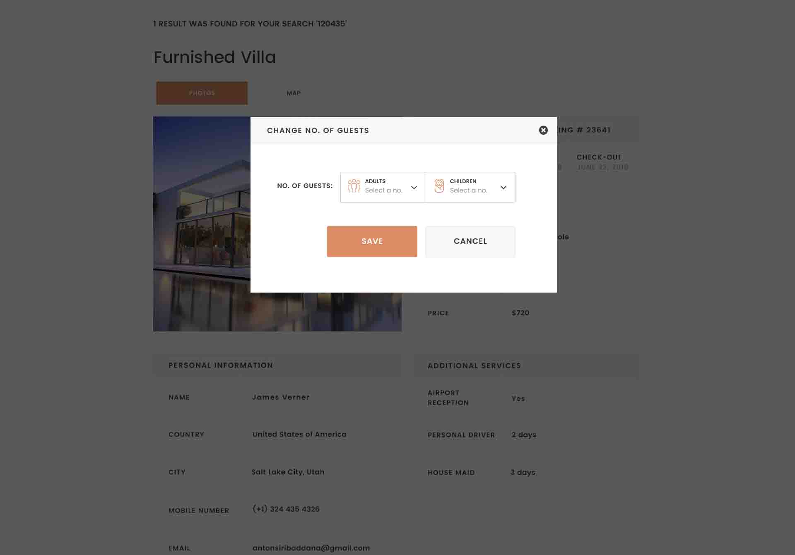

After changing no of guests, the system should sent confirmation message automatically to the user with details of new updated no of guests

**Changing package:**

The user can change his selected package and select another package.

After updating, confirmation message should be send to the user with the new selected package.

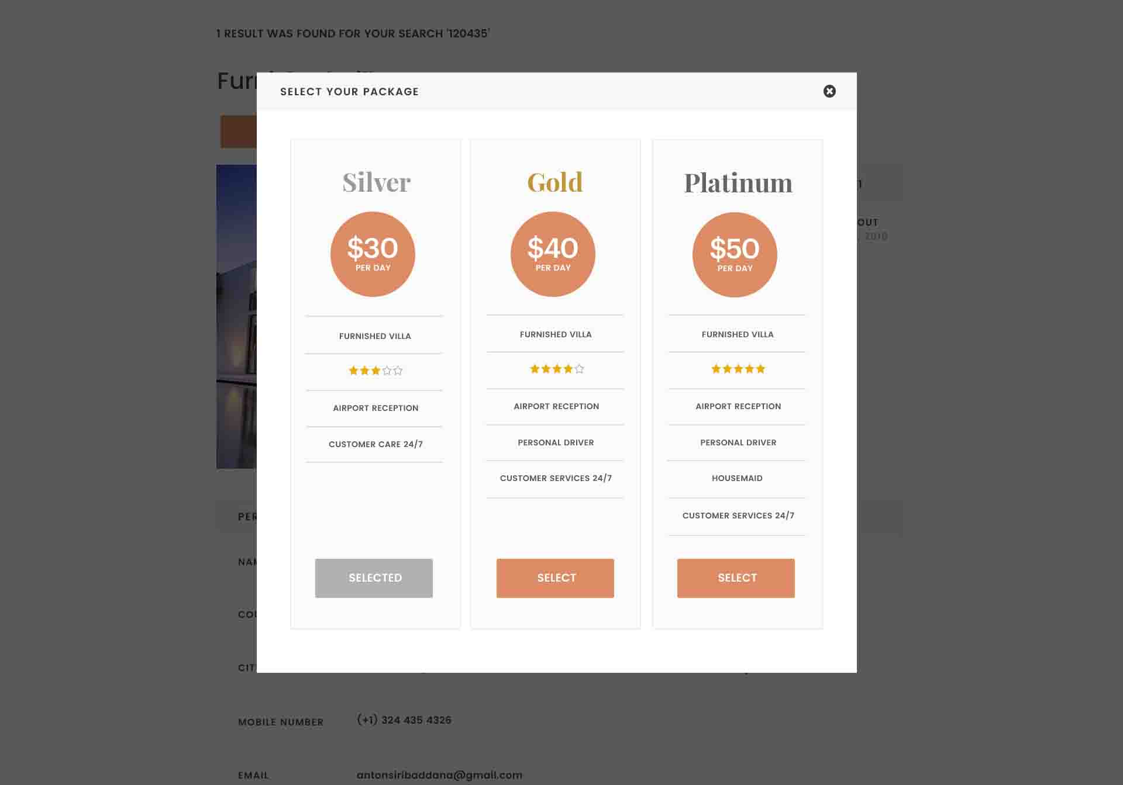

## Developing:

Included meals should appear here

**After any update, pop up appear and update email is send to the user (like the guest house).**

## Developing:

* add included African meals
* if he was VIP, add message “VIP CLIENT” before “thanks guest name” for all templates

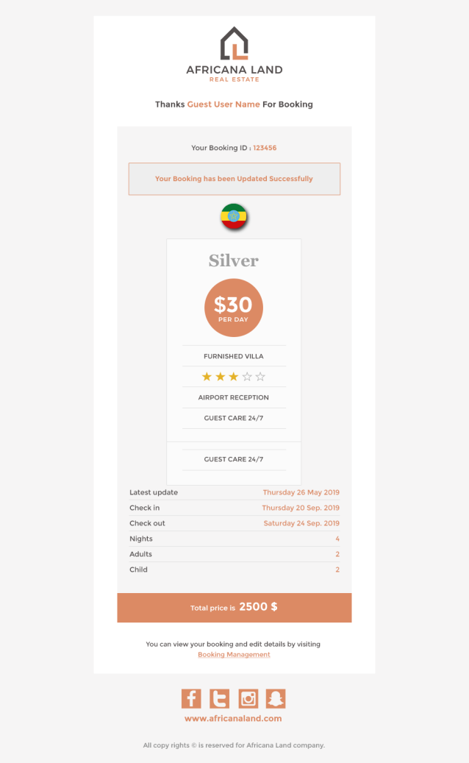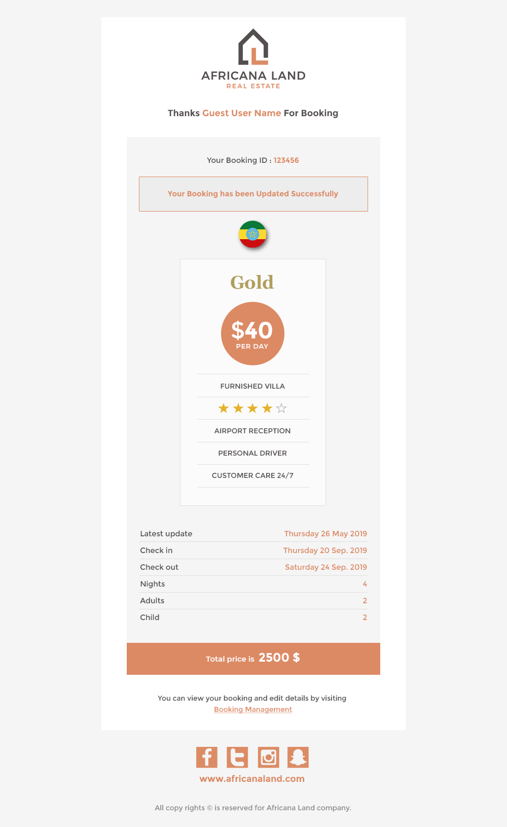

**Cancel Booking:**

If user select cancel booking, pop up appear for him asking him about the reason, then if he canceled the booking, the system send confirmation email to him automatically.





## Developing email templates:

* add included African meals
* if he was VIP, add message “VIP GUEST” before “thanks guest name” for all templates

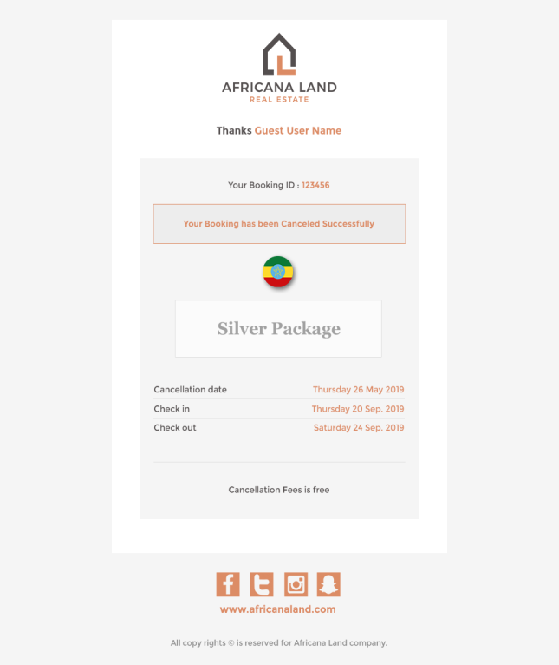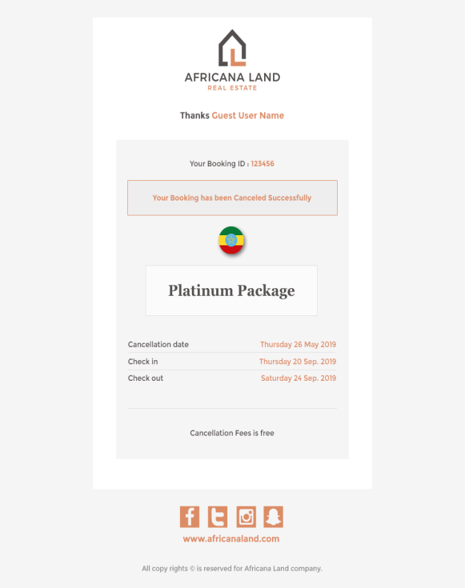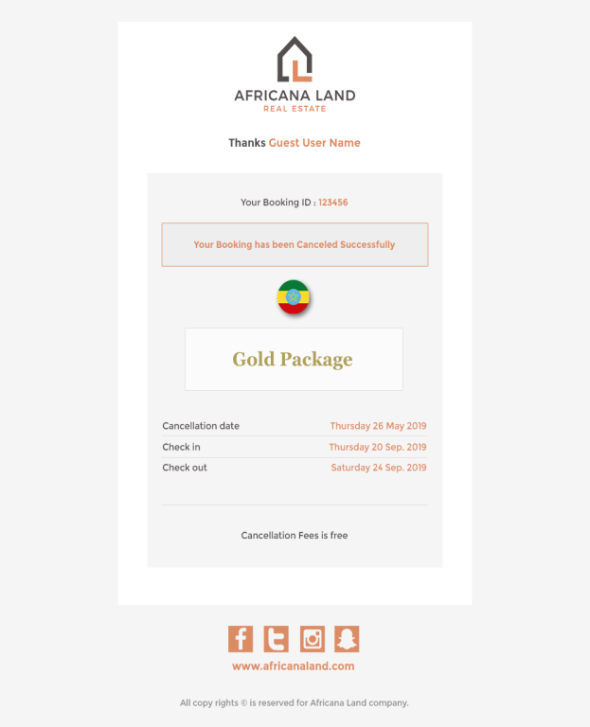

**Our partner page:**

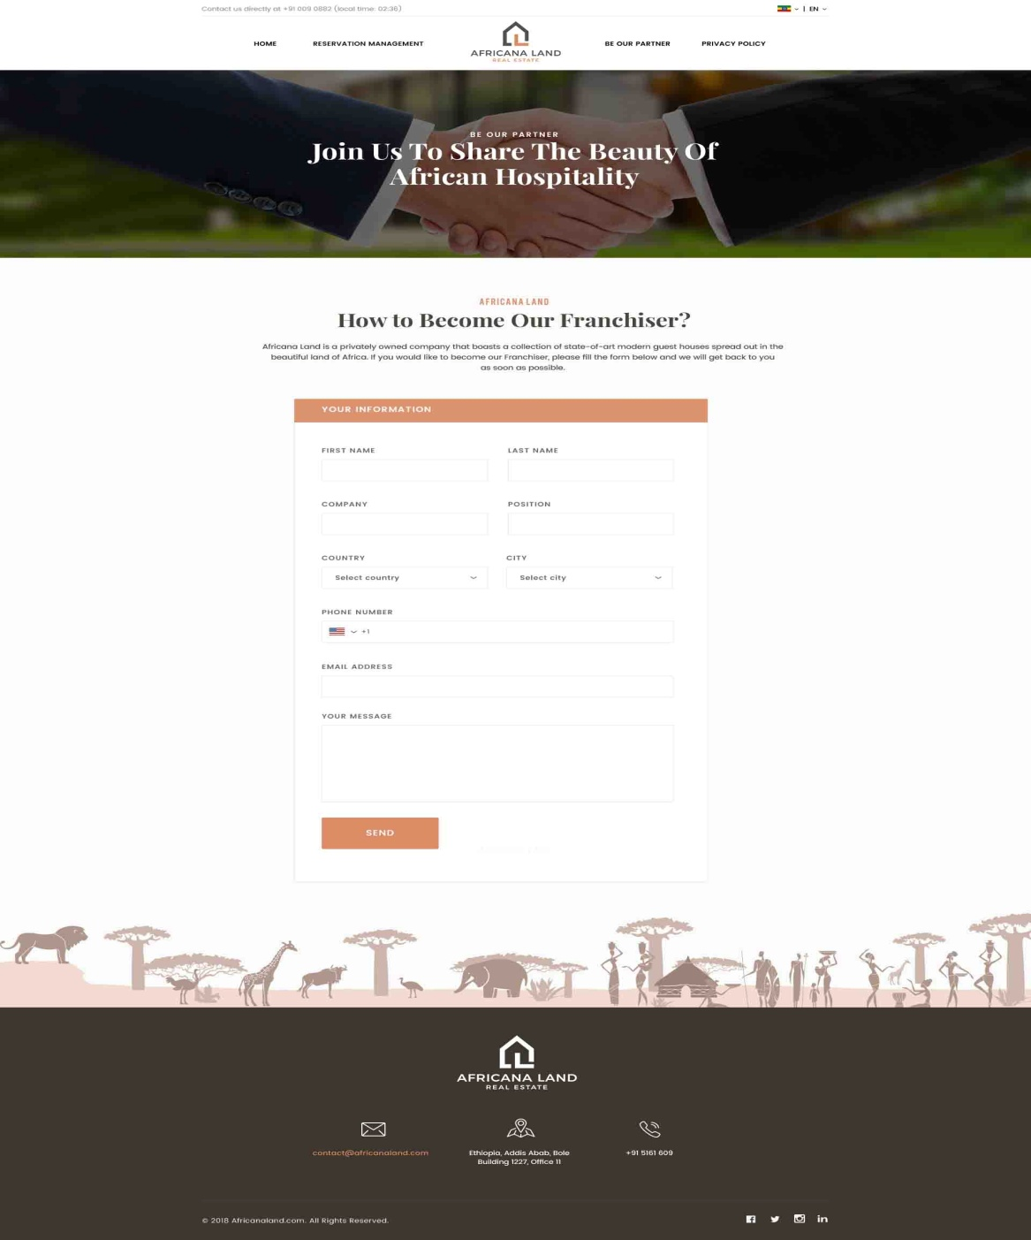

After user save data, his saved data is sent to the company.

**In control panel**, admin can see partners, see message details and reply to them through Partners tab.

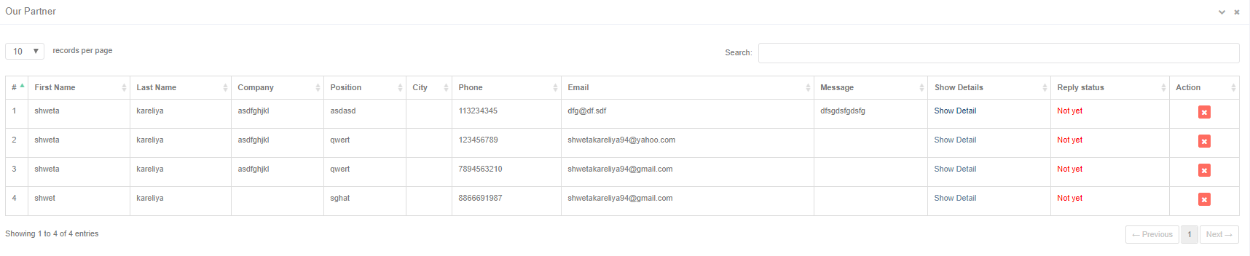

**Privacy policy page:** user can read the privacy policy from this page

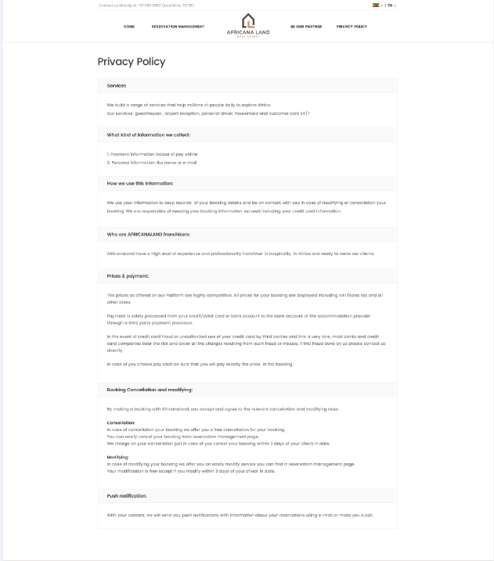

In Control Panel, Admin can change its content from Admin part-> privacy policy. Admin can write his data and format it as he wants.

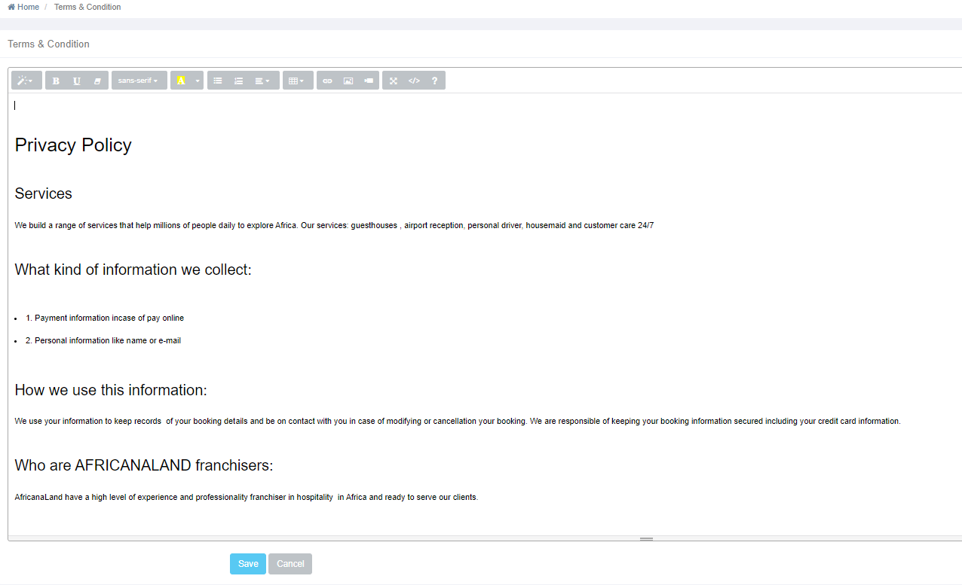

Control panel

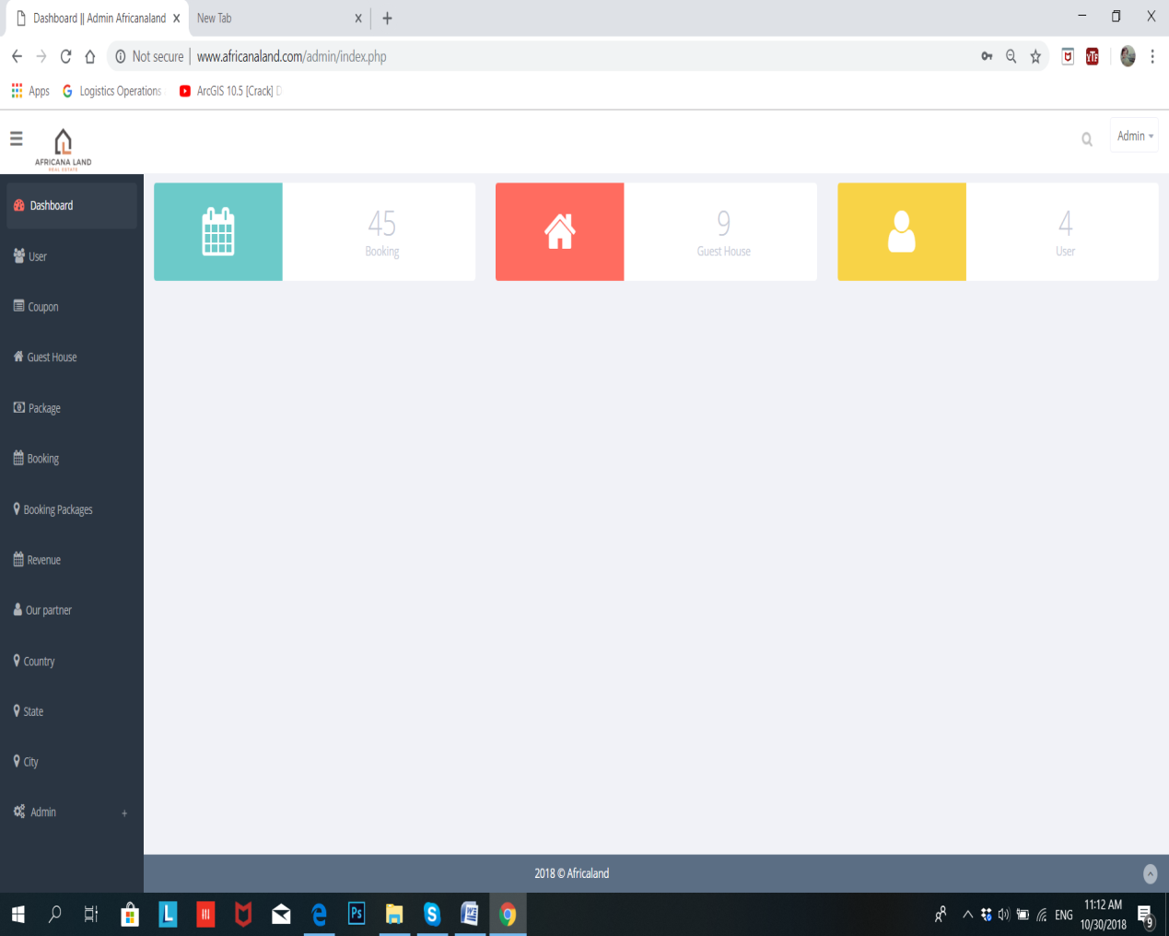

# **Admin Privileges:**

* After login, Admin can see link at the upper right corner of the page, to change the control panel from guest house control panel to be the Real estate control panel.
* Add /update/ approve and delete user.
* Add/update or delete coupon with its data (valid from date, to date, discount percentage)
* Add/ update or delete guest house.
* Approve/ reject added guest house by franchisor.
* Update/activate or deactivate packages data.
* Add/ update or delete guest house booking.
* Add/ update or delete package booking.
* View revenue report and set the percentage of the main (mother) company profit.
* View requests of partners and can reply them.
* Add/update or delete city.
* Add/update or delete states.
* Add/update or delete Country (franchisor).
* Change the profile of the company
* Set/change privacy policy
* Manage his profile (image, password , profile name, email)
* Has no PayPal account. No gateway for him

## **Developing Admin privileges:**

* In users part, no franchisor account, it is added from add country option.
* Allow admin to add paid gateway (like PayPal, stripe) of the franchisor if possible.
* Should add new part named VIP Clients (to allow admin add the membership number, personal information of the VIP)
* **Note**: the advantages of VIP are added on the VIP card which is delivered to that client. Not related to the system.

# **Sub Admin:**

* Can’t delete franchisor (Country) account.
* Add/update or delete coupon with its data (valid from date, to date, discount percentage)
* Add/ update or delete guest house.
* Approve/ reject added guest house by franchisor.
* Update/activate or deactivate packages data.
* Add/ update or delete guest house booking.
* Add/ update or delete package booking.
* View revenue report but can’t change the percentage of the main (mother) company profit.
* View requests of partners and can reply them.
* Add/update or delete city.
* Add/update or delete states.
* Manage his profile (image, password)
* Has no PayPal account. No gateway for him
* Add/change privacy policy

# **Franchisor:**

* Add/update or delete coupon with its data (valid from date, to date, discount percentage)
* Add/ update or delete pending guest house (can’t be seen to guests till admin approve it) .
* Update/activate or deactivate packages data.
* Add/ update or delete guest house booking.
* Add/ update or delete package booking.
* View revenue report but can’t change the percentage of the main (mother) company profit.
* Pay weekly by adding/attaching the paid bill. View his bills.
* Has PayPal account. Has his own gateway which pay from it to the main company.
* Add/update or delete city.
* Add/update or delete states.
* Manage his profile (image, password)

Control panel development

1. Add African meals in guest house (add, update) in **additional services** part with its country.

The part of Africana Meals may look like this:

Africana Meals

Free

50 $

Breakfast

Free

120$

Lunch

✓

Free

0 $

Dinner

Cancel

Save

1. In **packages**: Add included African meals in packages (add, update). The same as it in guest house part.
2. In **Booking**, don’t allow user book a guest house (from traditional search) after than 30 day of the current date.
3. **For users Tab:** Remove adding franchisor account from users tab, let it from country. Admin can add/update/ delete the country (with all franchisor data in same page).
4. **For guest houses:** (let delete button move the guest house to deleted guest houses, don’t show deleted guest houses to frontend users (website visitors). Admin can restore or delete permanently that guest house.
5. The website (front end pages and control panel) should be compatible with mobile devices and tablets and PC.
6. **Messaging part: as in the real estate in same idea. Explained in the real estate project- messages part.**
7. **Notifications: any process occur in the website should appear as notifications in its correct way, in addition, every new message appear with its notification.**

Messages part

1. Create new messages: admin create new messages, select for all or custom. In case of custom, he selects custom franchisors or specific franchisors. Admin can send message to the subadmin also and vice versa.

Message appear like this :

Admin or sudadmin who is logging in.

From

Select added country by admin 

All or Custom

To

Late payment 

Booking issues

Client complaint

others

Type

In case of others, write the other type.

Attach file



Enter subject

Subject

Write Content here

The messages is send in current system data and time with “UnRead” status till receiver open it, it becomes “Read”

Inbox, sent and deleted messages are like traditional messaging systems.

Send

Cancel

Inbox looks like:

Search by

|  |  |  |  |  |  |  |
| --- | --- | --- | --- | --- | --- | --- |
| ID | Sender Email | Subject of message | date | View details | Reply | delete |
| 1 | [ahmed@gmail.com](mailto:ahmed@gmail.com) | Welcome to africanaland | Monday, 1/11/2018 | *View* | C:\Users\Mahmoud\Desktop\th (2).jpg |  |
| 2 |  |  |  |  |  |  |
|  |  |  |  |  |  |  |
|  |  |  |  |  |  |  |
|  |  |  |  |  |  |  |

Enter Email

<< < 1 pages > >>

In case of Reply:

To : system enter sender’s email automatic

Attach file



Write reply here

Cancel

Send

Previous message here

Subject: add “Re” plus the last subject

**Deleted messages:**

Incase of restore, it appear in inbox.

Search by

|  |  |  |  |  |  |  |
| --- | --- | --- | --- | --- | --- | --- |
| ID | Sender Email | Subject of message | date | View details | Restore | Delete |
| 1 | [ahmed@gmail.com](mailto:ahmed@gmail.com) | Welcome to africanaland | 1/11/2018 | *View* |  |  |
| 2 |  |  |  |  |  |  |
|  |  |  |  |  |  |  |
|  |  |  |  |  |  |  |
|  |  |  |  |  |  |  |

Enter Email

<< < 1 pages > >>

**Sent messages:**

If Ahmed sent message to Ali, Ali opened the message, the status in the sent messages (in Ahmed sent messages) changes from “Unread” to be “Read”.

|  |  |  |  |  |  |
| --- | --- | --- | --- | --- | --- |
| ID | Sent to | Subject of message | date | status | View details |
| 1 | [ahmed@gmail.com](mailto:ahmed@gmail.com) | Welcome to africanaland | 1/11/2018 | **Unread** | *View* |
| 2 | Mohamed@gmail.com | Hello | 10/10/2018 | **Read** | *View* |
|  |  |  |  |  |  |
|  |  |  |  |  |  |
|  |  |  |  |  |  |

Search by

<< < 1 pages > >>

Enter Email or subject 

1. **VIP Clients (VIP Guests)**

Add New VIP Guest

Filter by

Country 

Membership ID 123456

|  |  |  |  |  |  |  |  |  |  |  |  |  |
| --- | --- | --- | --- | --- | --- | --- | --- | --- | --- | --- | --- | --- |
| **ID** | **Membership ID** | **Full name** | **gender** | **nationality** | **Stay country** | **mobile** | **Phone** | **email** | **nationality** | **Join date** | **Update** | **Delete** |
| 1 | 123456A | Ali Osam | Male |  |  | 0113456 | 0501356 | [Ali@gmail.com](mailto:Ali@gmail.com) | Ethiopia |  | … | **X** |
|  |  |  |  |  |  |  |  |  |  |  |  |  |
|  |  |  |  |  |  |  |  |  |  |  |  |  |
|  |  |  |  |  |  |  |  |  |  |  |  |  |
|  |  |  |  |  |  |  |  |  |  |  |  |  |
|  |  |  |  |  |  |  |  |  |  |  |  |  |

ssss

**Add New VIP GUEST:**

Join date is Current date automatically and not appear for user

Enter first name

First Name

Enter last name

Last name

Male Female

Gender

Nationality

Select country 

Resident Country

Select country 

Select State 

State

Select City 

City

Enter Address in Multiline

Address

Allow admin to write it manually or system generates it automatically.

Email

Flag icon +966 - 123456789

Membership ID

Enter Email

123456

Flag icon  +966 - 123456789

Phone

Mobile

save

cancel

In case of delete, move deleted VIP Guests to deleted VIP.

Admin only can delete permanently or restore. Sub admin cant. Sub-admin deletes and the deleted object moves to deleted items. Sub-admin can’t delete permanently.

1. **Franchisor (relating to the country) pay weekly 20% (20 % from total price paid for every booked guest house or package) for the main company (this percentage can be changed by admin or sub-admin as mentioned before). He attach the paid bill and it appears in revenue part**

**In franchisor control panel, add option of “add payment”. It looks like:**

* **Franchisor attach the paid bill weakly, if franchisor didn’t pay for a week, he should pay to the 2 weeks. May be in the same bill no problem but pay the total amount of both weeks and so on)**
* **Franchisor (add payment) look like this**

From date

To date

Amount

1200 $

Attach paid bill

The paid bill

save

**Franchisor should see his payments in report (like in admin) but cannot change the percentage (20%).**

**Revenue Report (check it as whole)**

|  |  |  |  |  |  |  |  |
| --- | --- | --- | --- | --- | --- | --- | --- |
| **ID** | **Booking No** | **Guest Name** | **Booking Type** | **Price** | **Payment Status** | **Payment Type** | **View Bill** |
| 1 | B123456 | Ahmed | Guest house | 1200 $ | Pending | Cash on arrival | Nothing |
| 2 | B123457 | Ali | Package | 2000 $ | cancelled | Stripe (credit card) | Nothing |
| 3 | B123458 | Mohamed | Guest house | 1500 $ | paid | Paypal |  |
|  |  |  |  |  |  |  |  |

Fix errors in payment type column.

Add column of “view Bill” in case of paid. On press on it, open the attached bill in pop up.